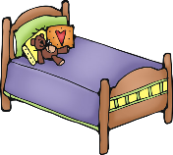
Job Chart
Cub Scouts Pack 15 & 115
Wolf Achievement 4e
NAME:_________________________
Week 1
Jobs | Sun | Mon | Tue | Wed | Thu | Fri | Sat
Week 2
Jobs | Sun | Mon | Tue | Wed | Thu | Fri | Sat
Week 3
Jobs | Sun | Mon | Tue | Wed | Thu | Fri | Sat
Week 4
Jobs | Sun | Mon | Tue | Wed | Thu | Fri | Sat

