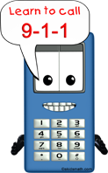
Emergency Phone Numbers

Emergency: 911

My Name:
Home Address:

Home Phone:
Allergies I have:

Police/Sheriff:
Fire Department:
Doctor:
Ambulance:
Poison Control:
Mom:
Dad:
Neighbor:
Other Emergency Contact:

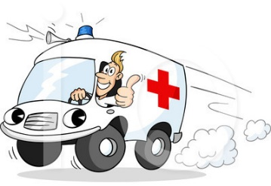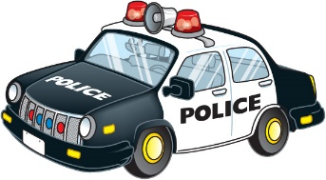
Emergency Phone Numbers

Emergency: 911

My Name:
Home Address:

Home Phone:
Allergies I have:

Police/Sheriff:
Fire Department:
Doctor:
Ambulance:
Poison Control:
Mom:
Dad:
Neighbor:
Other Emergency Contact:

