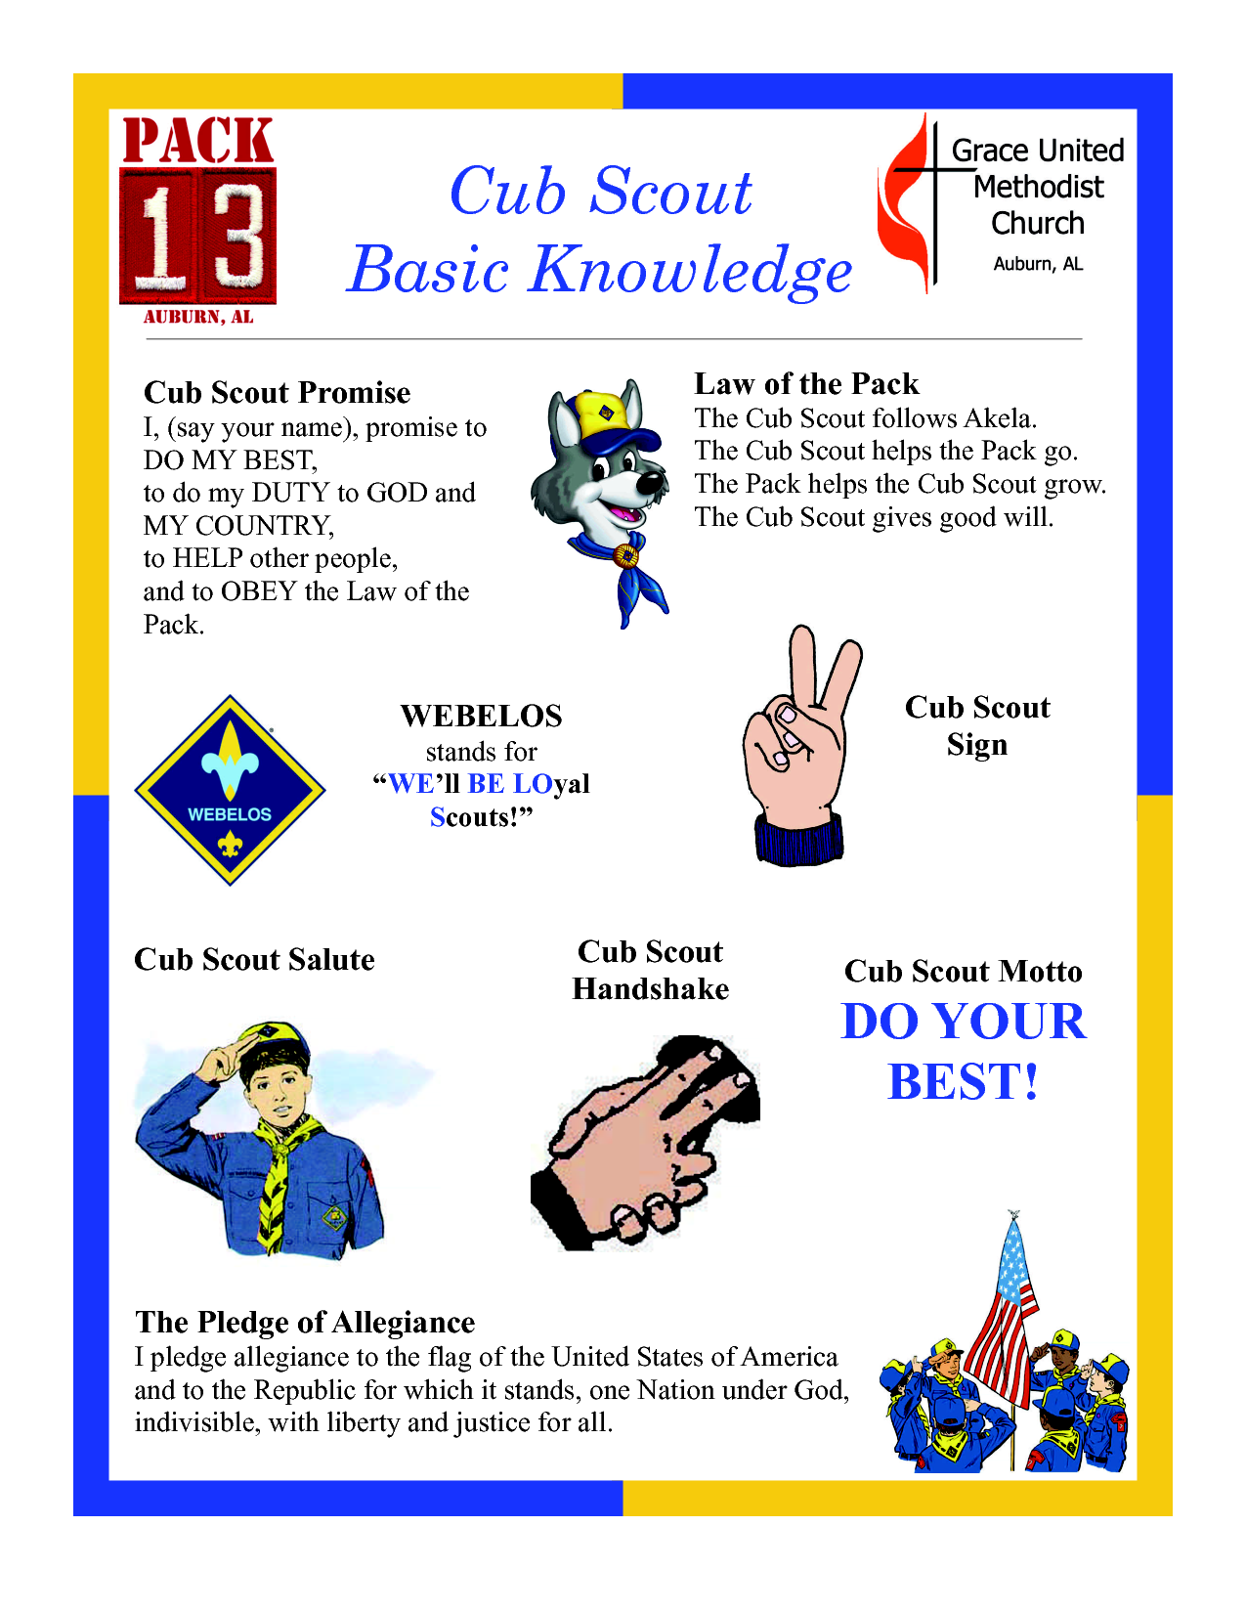

Cub Scout

Basic Knowledge