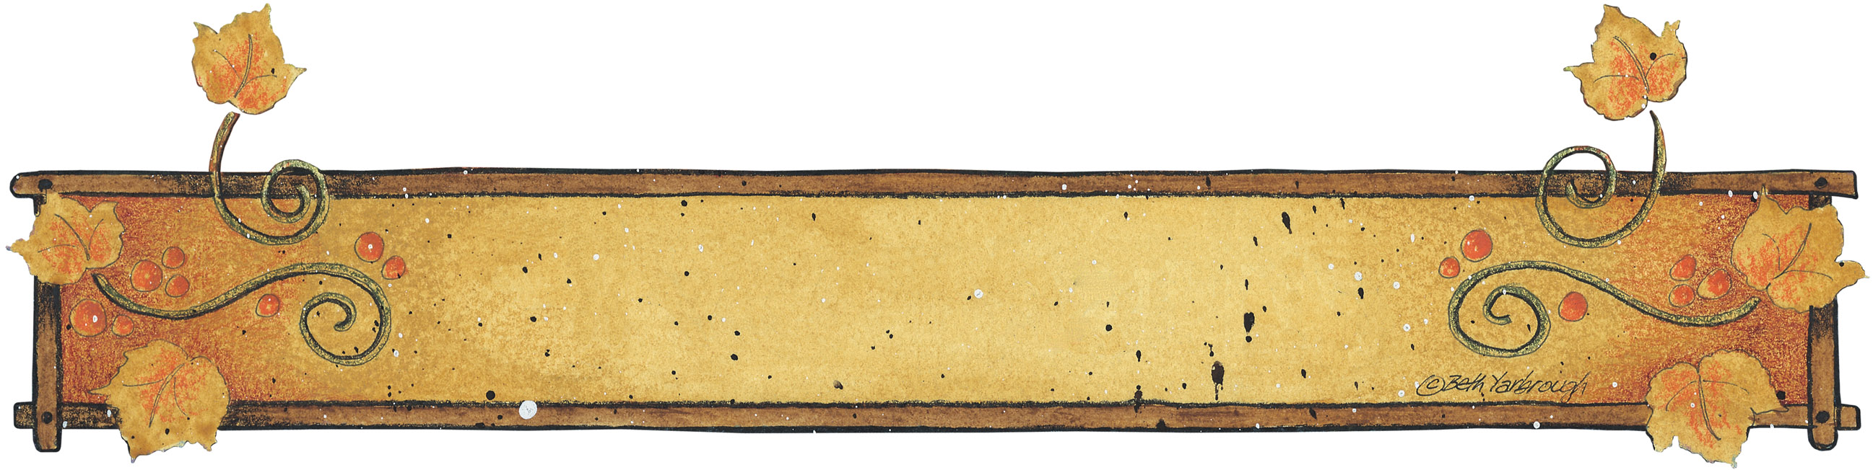

Quick Chili
Julie Garner
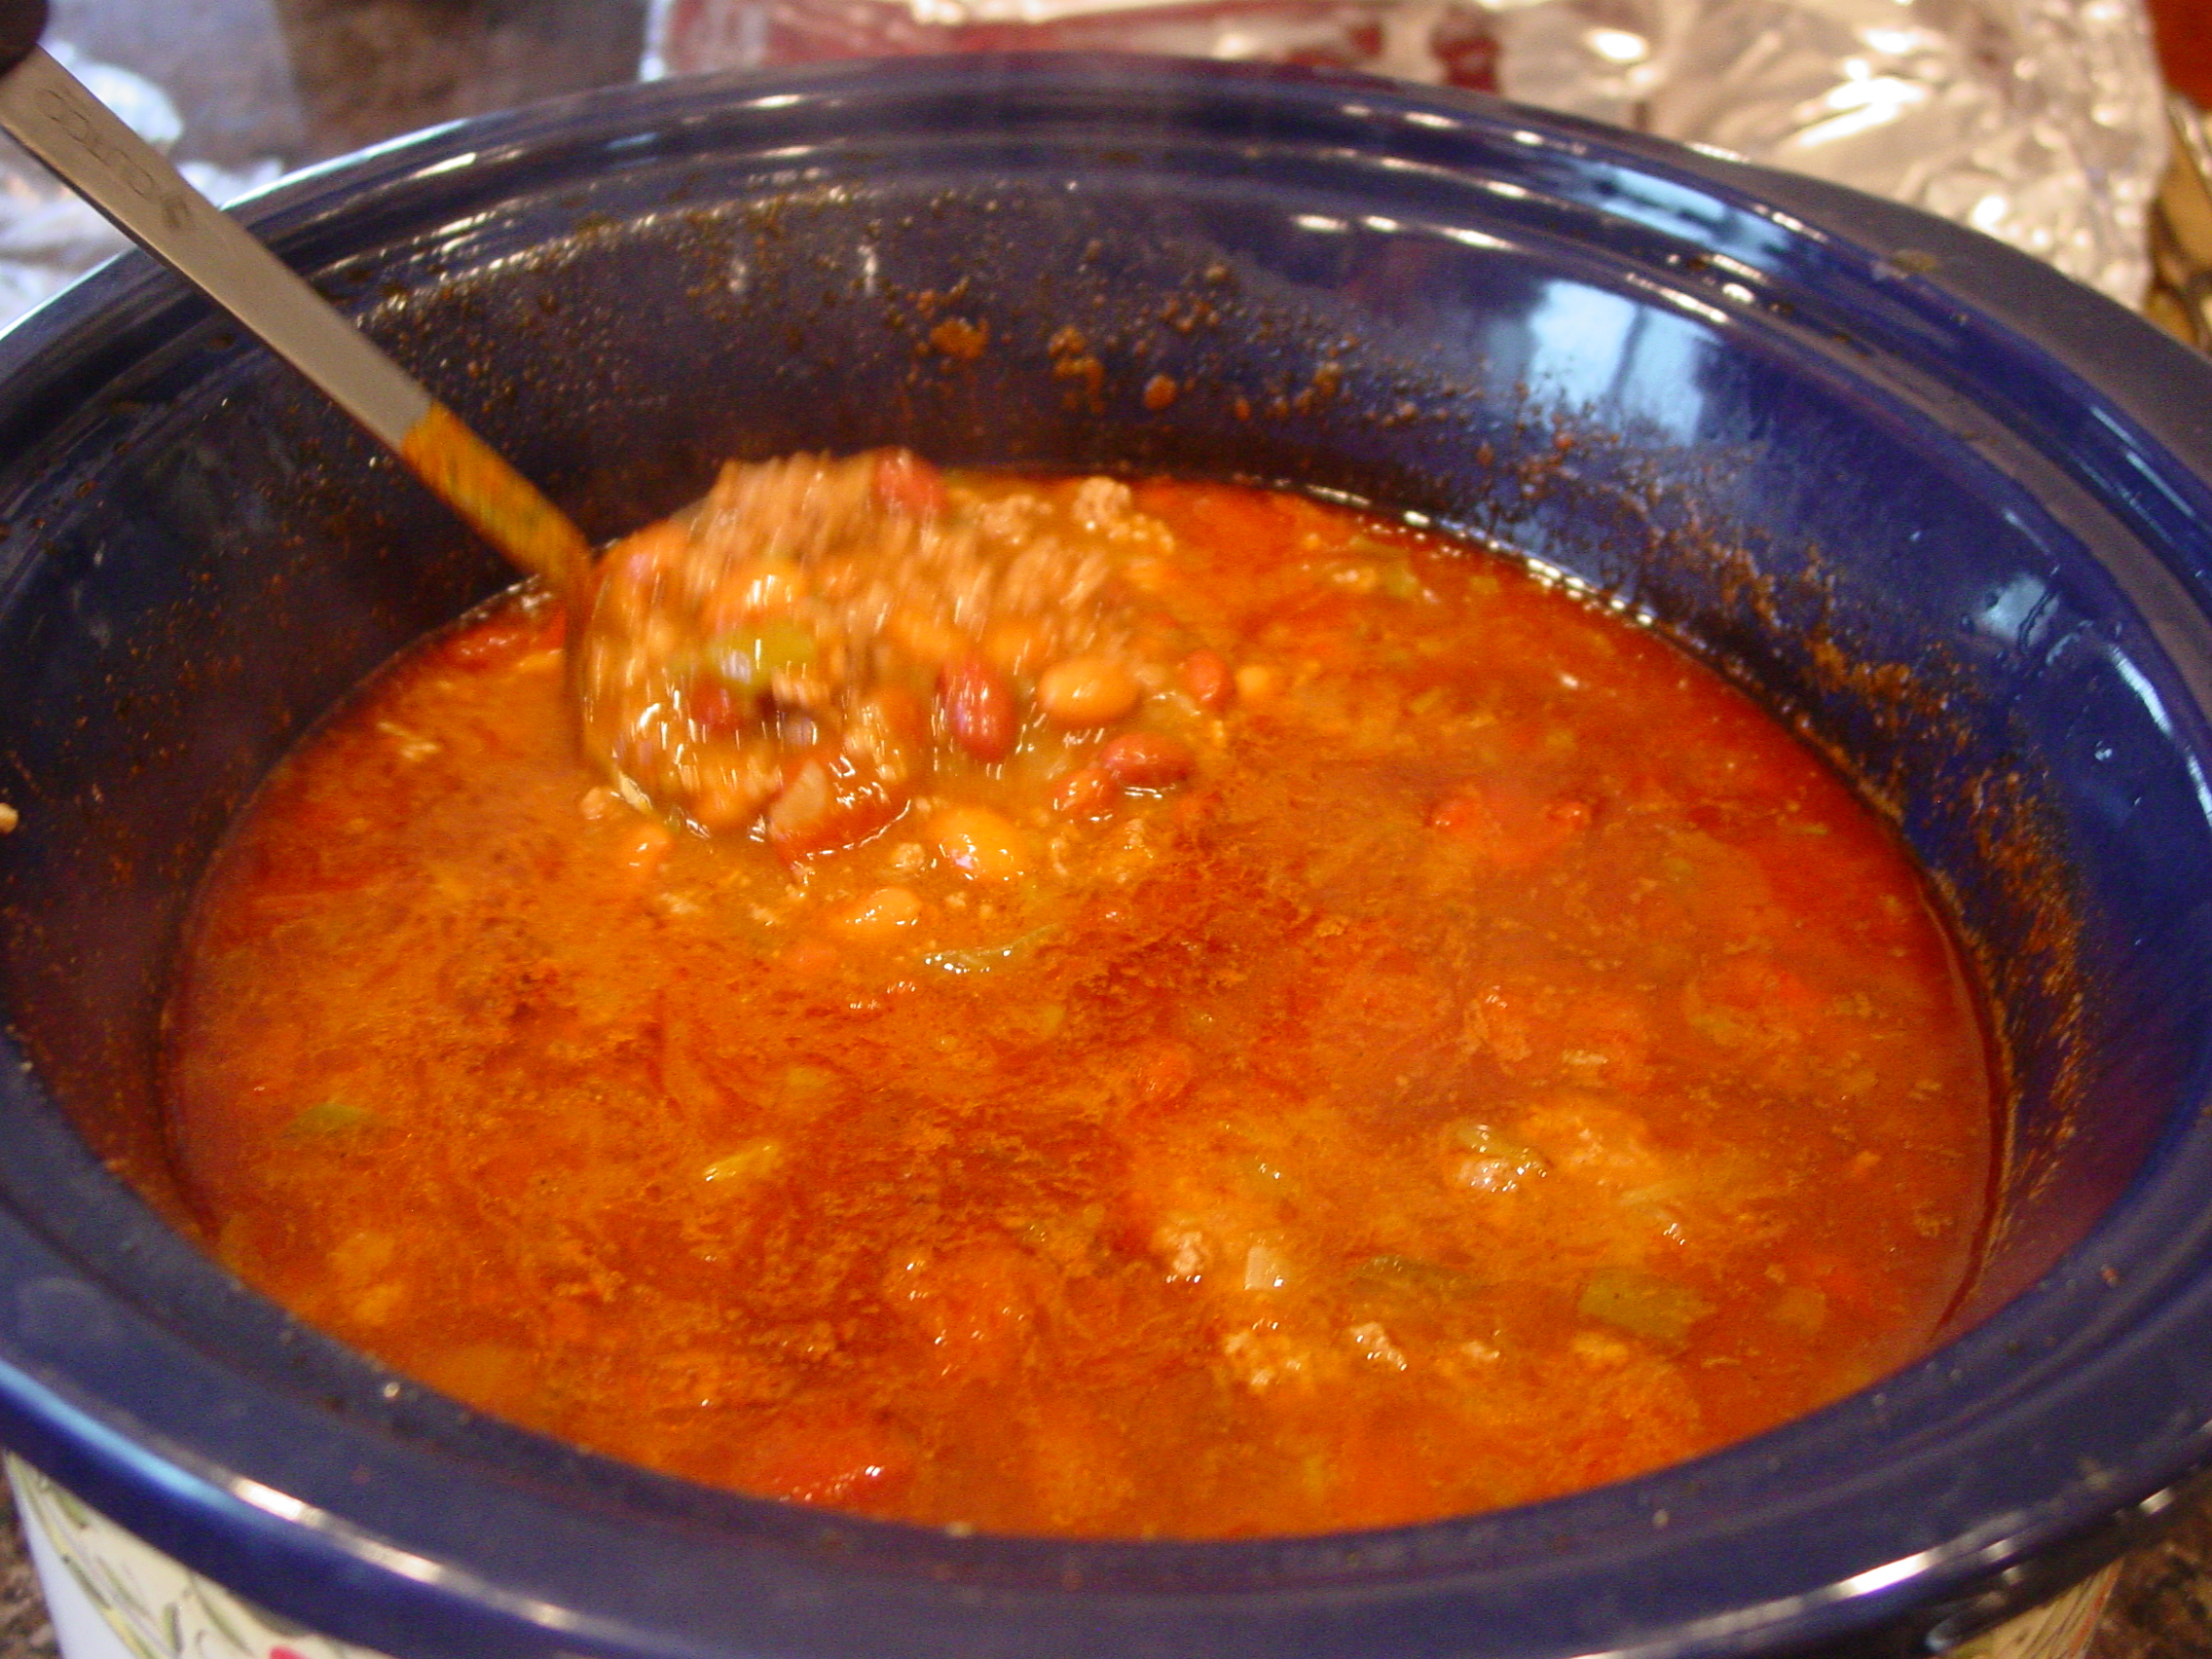
1 ½ lbs. ground beef
1 onion (chopped)
1 ½ green bell peppers (chopped)
Brown together and drain
Add:
1 sm. can chopped green chili’s
2 Cans pinto beans (drained)
2 Cans red kidney beans (drained)
2 Cans (sm) tomato sauce
1 large can chopped tomatoes
1 pkg Chili mix OR 2 T. Cumin & 2 T. Chili Powder

Simmer in crock pot until warmed all the way through.

Cranberry Jell-O Salad
Jeanette Warren
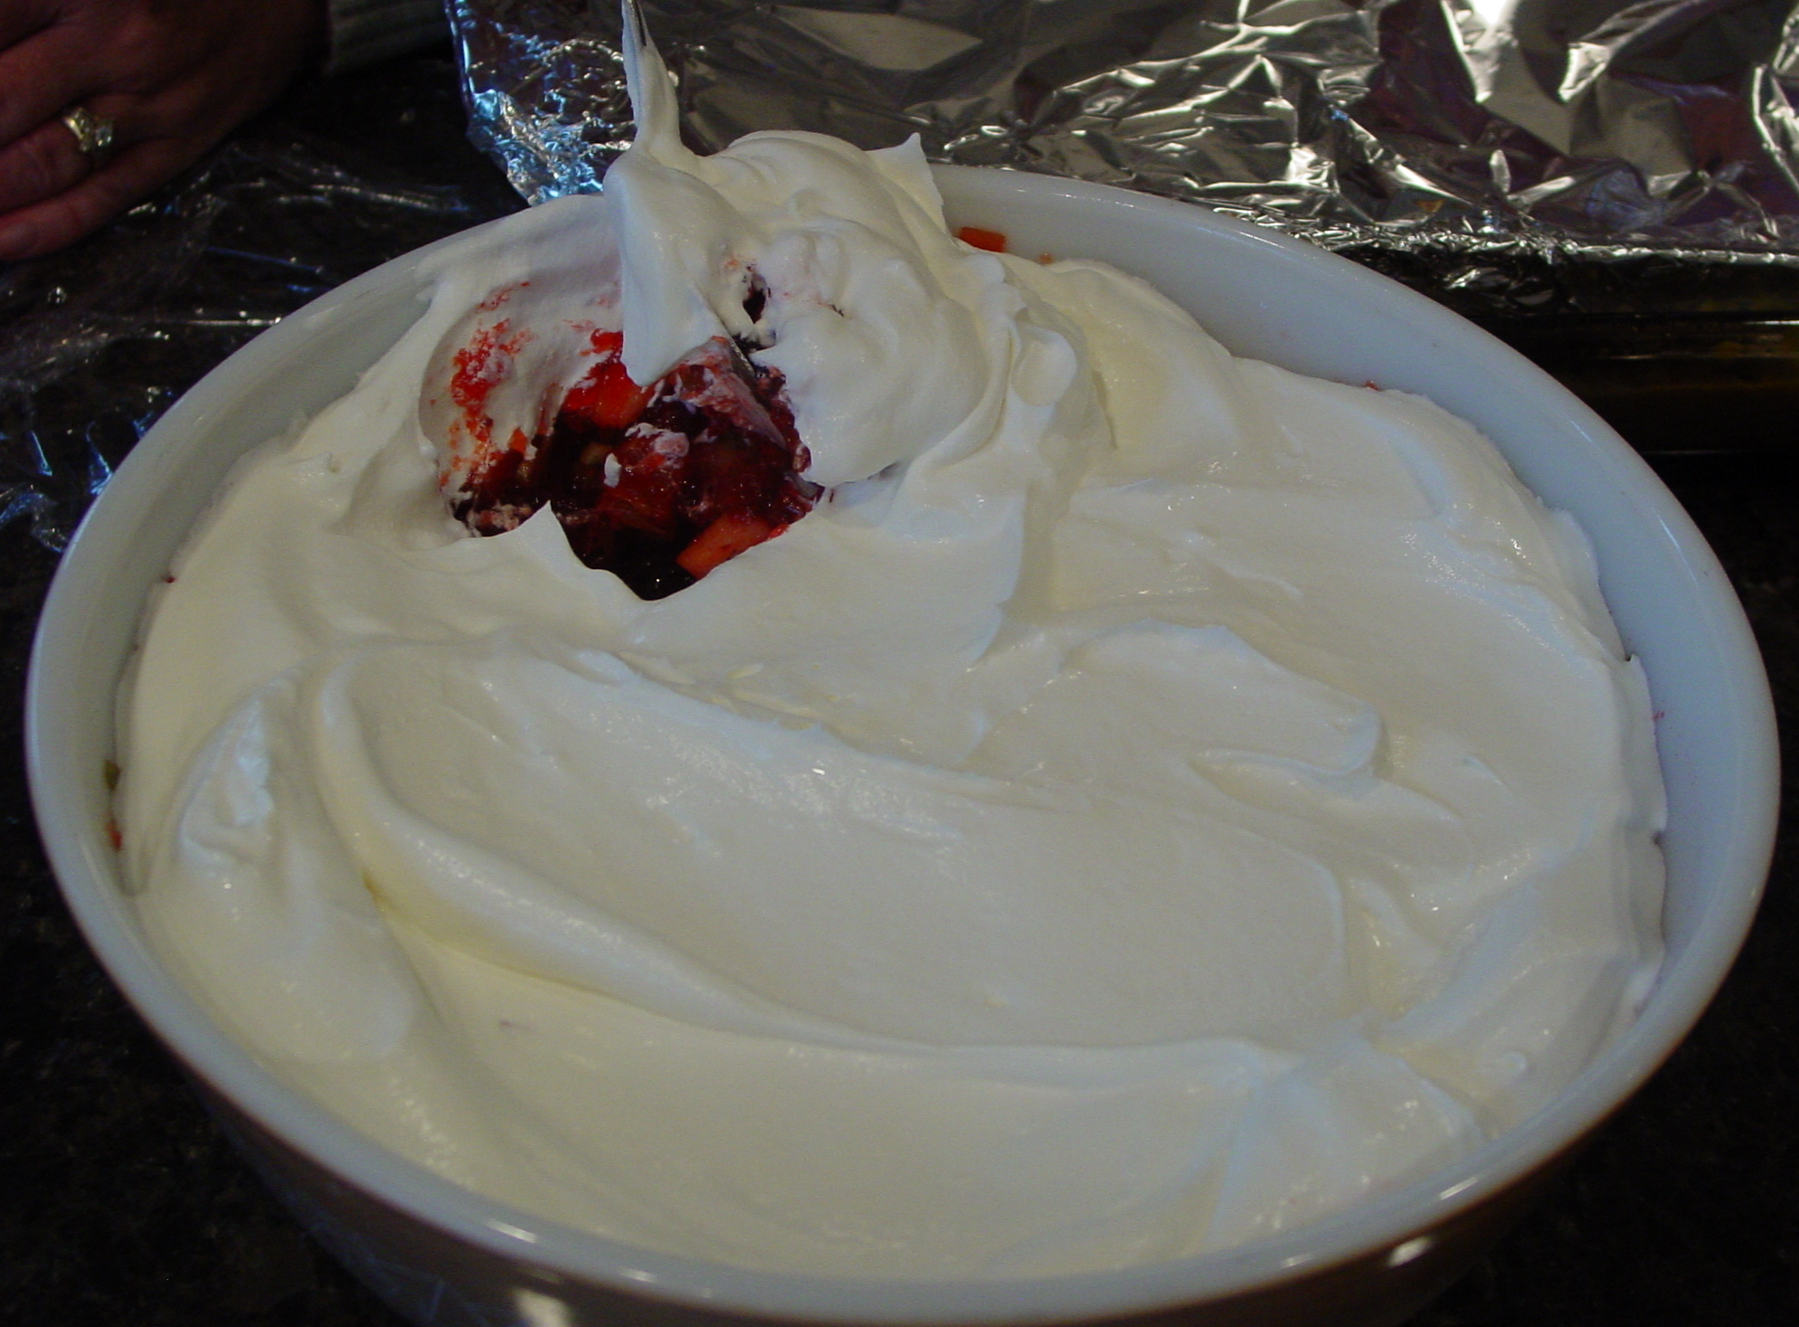

1 pkg. fresh Cranberry
1 Orange
2 C. Sugar
1 C. celery
2 Apples
½ C. Nuts
3-3oz. pkgs Cherry Jell-O

Chop cranberries & oranges. Mix with sugar and set overnight. Chop rest of ingredients and mix with Jell-O (pre-mixed). Add 2 drops red food coloring for more color.
Top with Cool Whip and nuts.

Jell-O And Mandarin Oranges

Beverly Jamison
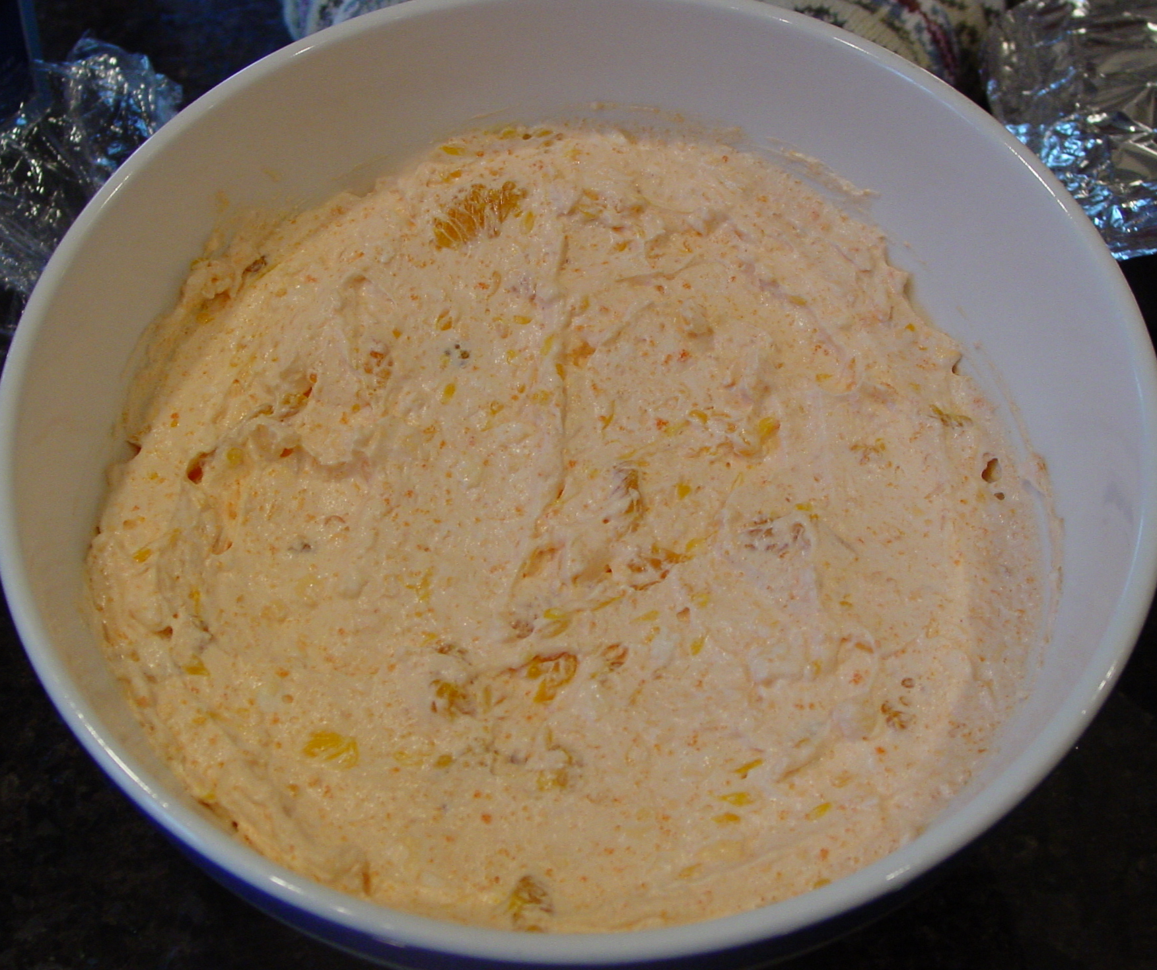
1 Can Mandarin oranges
1 Small Carton cottage cheese
1 Small Carton Cool Whip
1 package orange Jell-O

Drain oranges; mix Cool Whip and cheese. Sprinkle orange Jell-O over. Mix well. Fold in oranges. Chill well.

Cheesy Chicken & Rice Casserole
Amy Hamilton

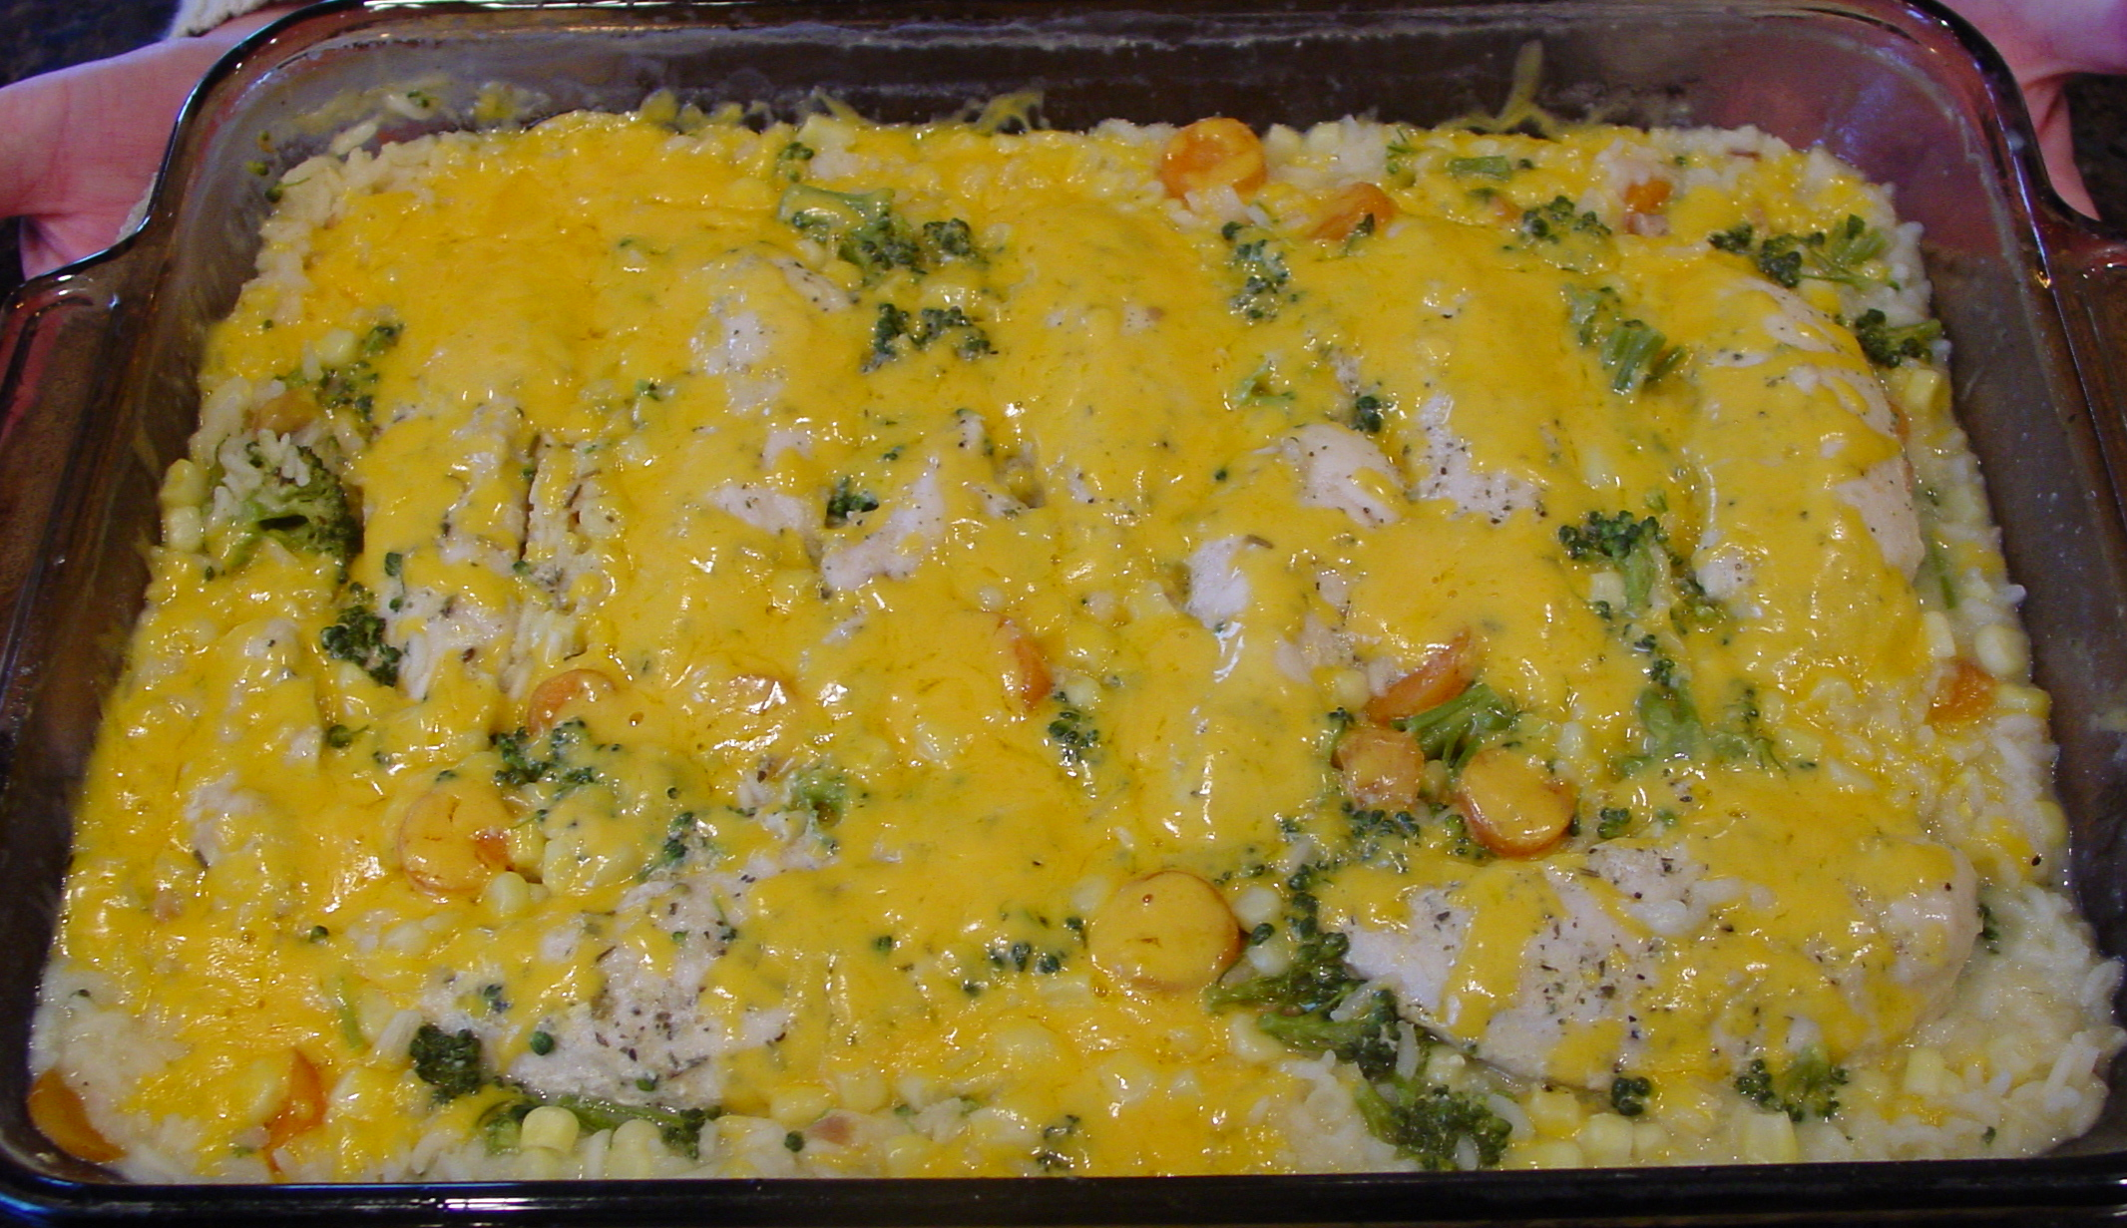
1 Can (10 ¾ oz.) Cream of Chicken soup
1 1/3 C. Water
3/4 C. uncooked long-grain white rice
½ t. Onion powder
2 C. Fresh or frozen vegetables
4 Chicken breasts halves or equivalent in Chicken tenders (boneless & skinless)
½ C. Shredded cheddar cheese
- Stir the soup, water, rice, vegetables and onion powder in a 12X8” shallow baking dish
- Top with Chicken (season chicken as desired – I used Montreal Chicken seasoning). Cover
- Bake at 375 for 45 min. or until done. Top with cheese

Variations:
Mexican Fiesta: In place of onion powder, use 1 tsp. chili powder. Substitute Mexican cheese blend for cheddar.
Italy: In place of onion powder, use 1 tsp Italian seasoning and substitute 1/3 C. shredded Parmesan for Cheddar.
Rocky Road Brownies
Pam Burgess

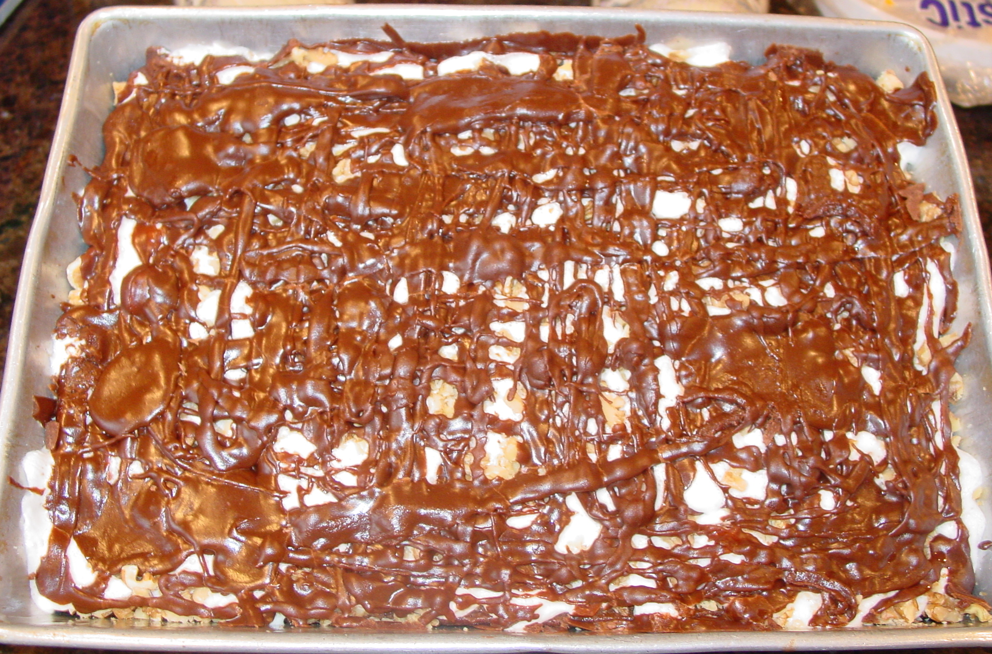
4 Eggs
2 C. Sugar
1 C. Margarine (melted)
2 T. vanilla
Mix well and add:
2 C. Flour
½ C. cocoa
1 t. salt

Mix all ingredients. Pour into 9X11 baking pan and bake at 350 for 35 min. When brownies are done, remove from oven & turn oven off. Sprinkle about 4 C. Mini marshmallows over brownies and place back in oven for about 5 min. (Until they are puffed) Remove from oven and sprinkle about ¾ C. chopped walnuts over marshmallows. Then drizzle fudge sauce over all. Serve hot or cold.
Fudge Sauce

About 5 minutes before brownies are done, melt in a saucepan, on med heat:
¼ C. Margarine
Add

¼ C. Cocoa
3 T. Milk
1 t. vanilla
2 ½ C. powdered sugar



