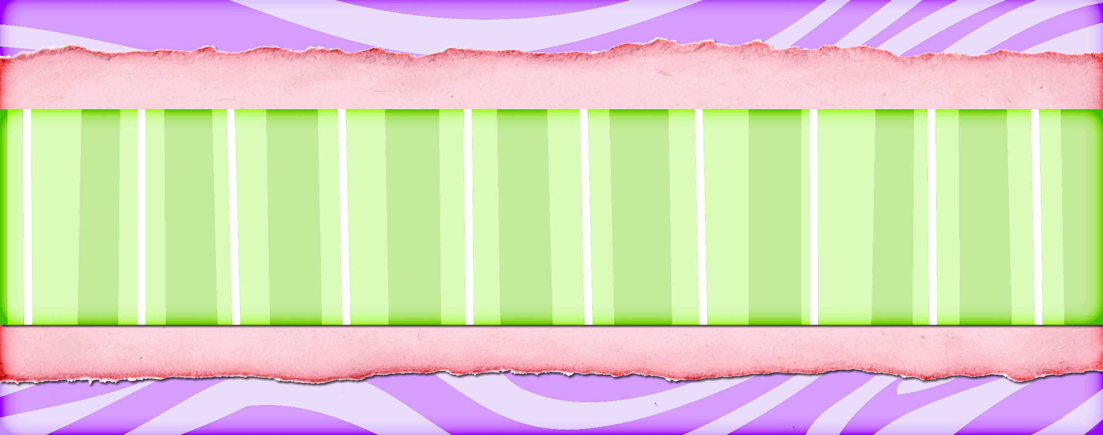

Girl Scout Tacos
Tanya Anderson
1 pound ground beef
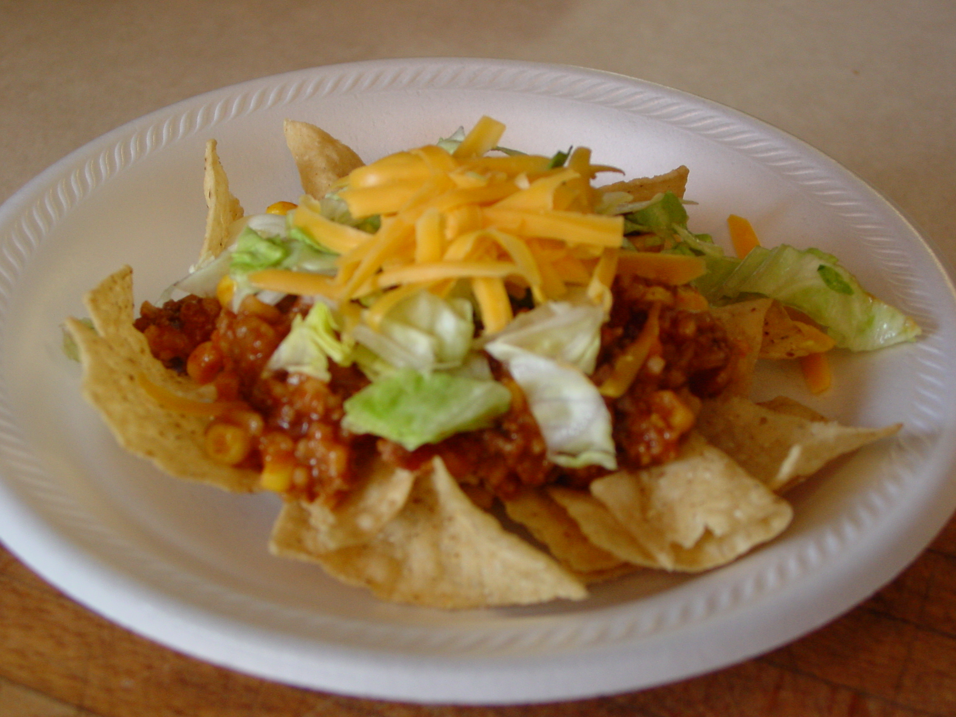
½ medium onion, chopped
(or 3 Tbsp dried onion flakes)
1 pkg taco seasoning
1 8 oz can tomato sauce
1 cup water
½ cup rice
1 16 oz can stewed chopped tomatoes
1 16 oz can corn (kernel)

Brown and drain ground beef. In a large pot, combine beef and taco seasoning. Add remaining ingredients - add all the juice with the tomatoes and the corn too - and simmer until rice is tender. (It will be thick when it is ready, not soupy. The rice should absorb all the liquid.) Stir often to prevent scorching on the bottom of the pot. Serve on a bed of your favorite chips (Fritos, Doritos, etc.) and top with cheese, lettuce, sour cream, onions, peppers, salsa, olives, or any of your other favorite toppings. Enjoy!

Halibut and Salmon
Joleen Anderson
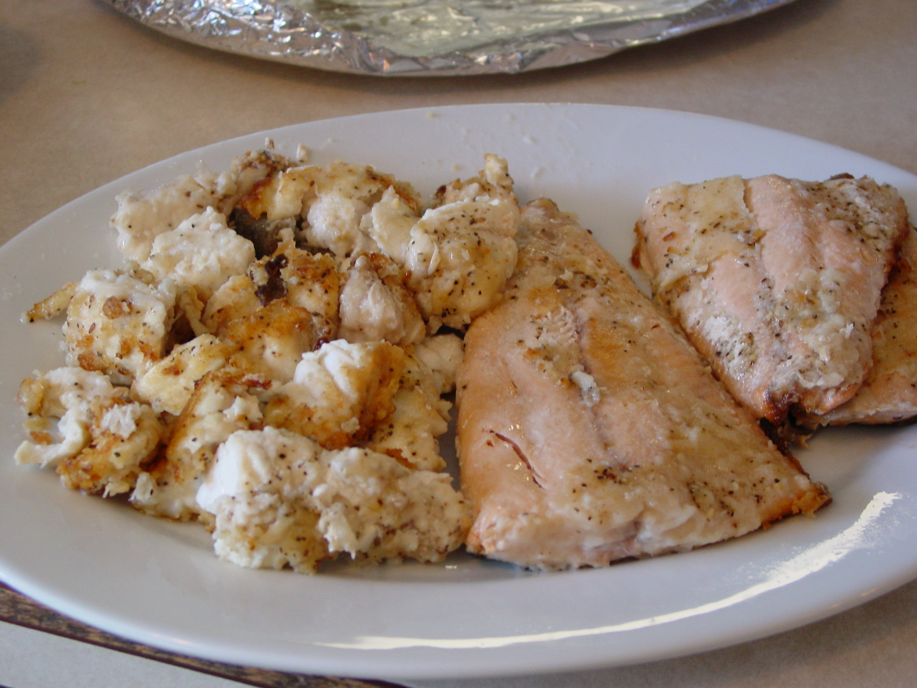
Prepare fish for frying
Mix together
Flour
Salt
Pepper
Season Salt

Coat both sides of fish in flour mixture
Fry slowly in butter.
Serve right away

Frozen Salad
Julie Garner

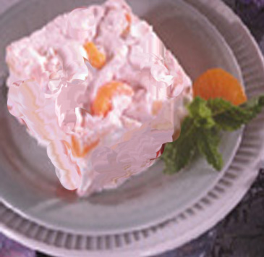
1 C. IMO (or 1 C. Sour Cream
1 pkg. dream whip or 1 carton Cool Whip
Stir Together

¾ C Sugar
2 tsp. lemon juice
1 Can Crushed Pineapple
1 Can mandarin Oranges
3 Bananas
¼ C. Maraschino cherries (quartered)

Add to above mixture. Cover and put in freezer until ready to serve

Cake Mix Cookies
Julie Garner

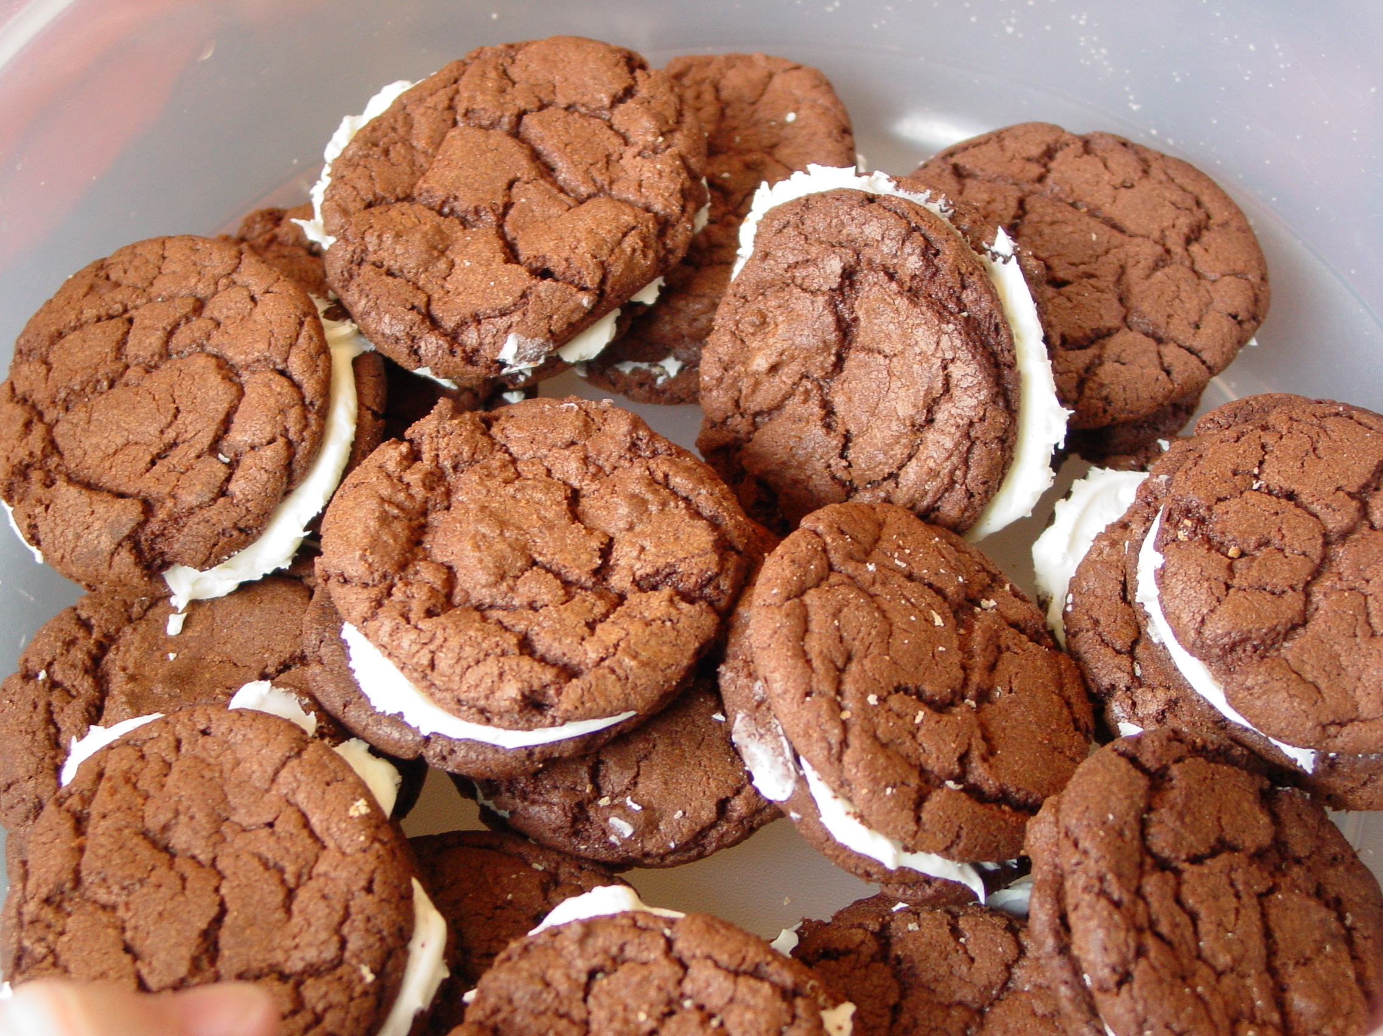
2 Eggs
1 (18.25 oz.) Pkg cake mix
½ C. vegetable oil

Mix together cake Mix, eggs, & oil in a large bowl. Make little balls with the dough and set on un-greased cookie sheets. Bake @ 350 for 4-10 min.
Serve alone, or put two together with filling:
Chocolate with frosting for Oreo’s
Nuts & frosting with applesauce cake, etc.



.

