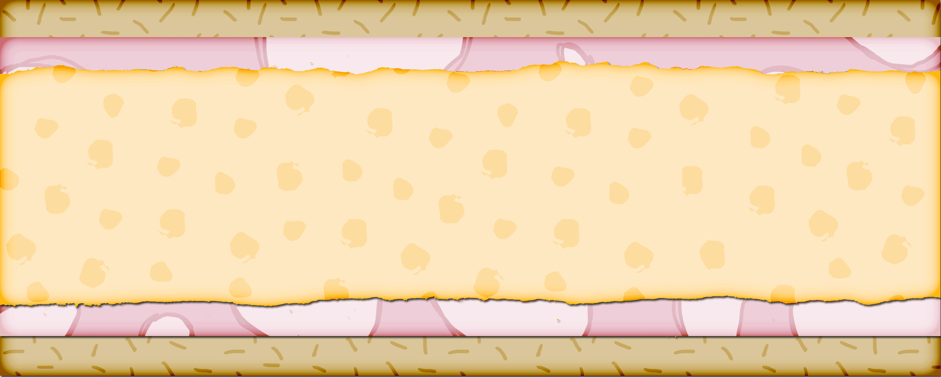

French Bread Pizza
Cindy Tolman
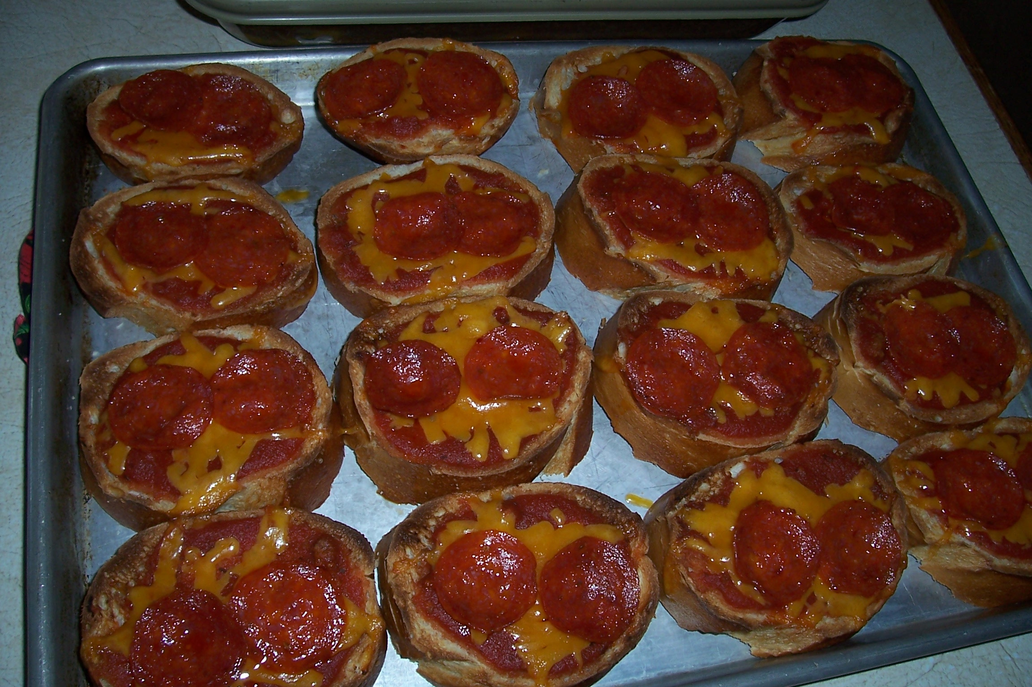
French Bread
Can Spaghetti Sauce
Cheese
Pepperoni (or other toppings)

Slice French bread and lay out on a cookie sheet. Toast in oven on both sides until golden. Spoon spaghetti sauce on to bread, and top with grated cheese and toppings. Broil until cheese is melted and serve

Rainbow Jell-O Salad
Karen Whiting
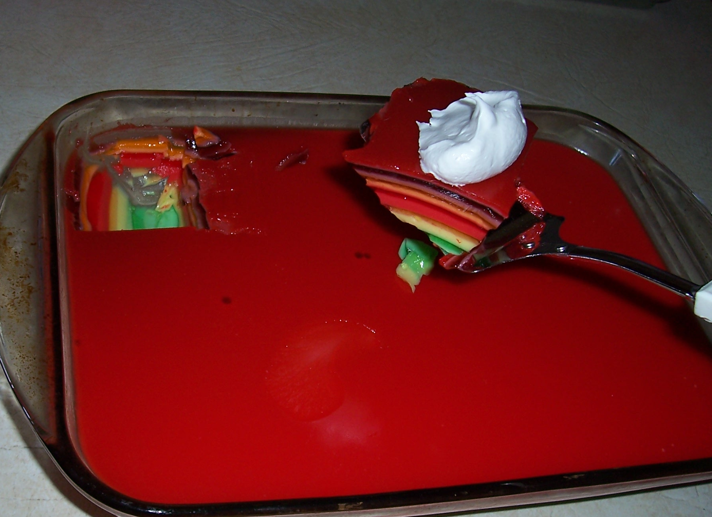
7 small jell-o packets (different colors)
1 pt plain yogurt or sour cream

Dissolve 1 pkg in 1 C. boiling water. divide in half. To half, add 1/3 C. yogurt. Pour into 9X13 in. pan. Let set. To the other half, add 3 T. cold water. Pour over 1st layer and let set. Repeat for all packages.

Fruit and Vanilla Yogurt Salad
Pam Burgess
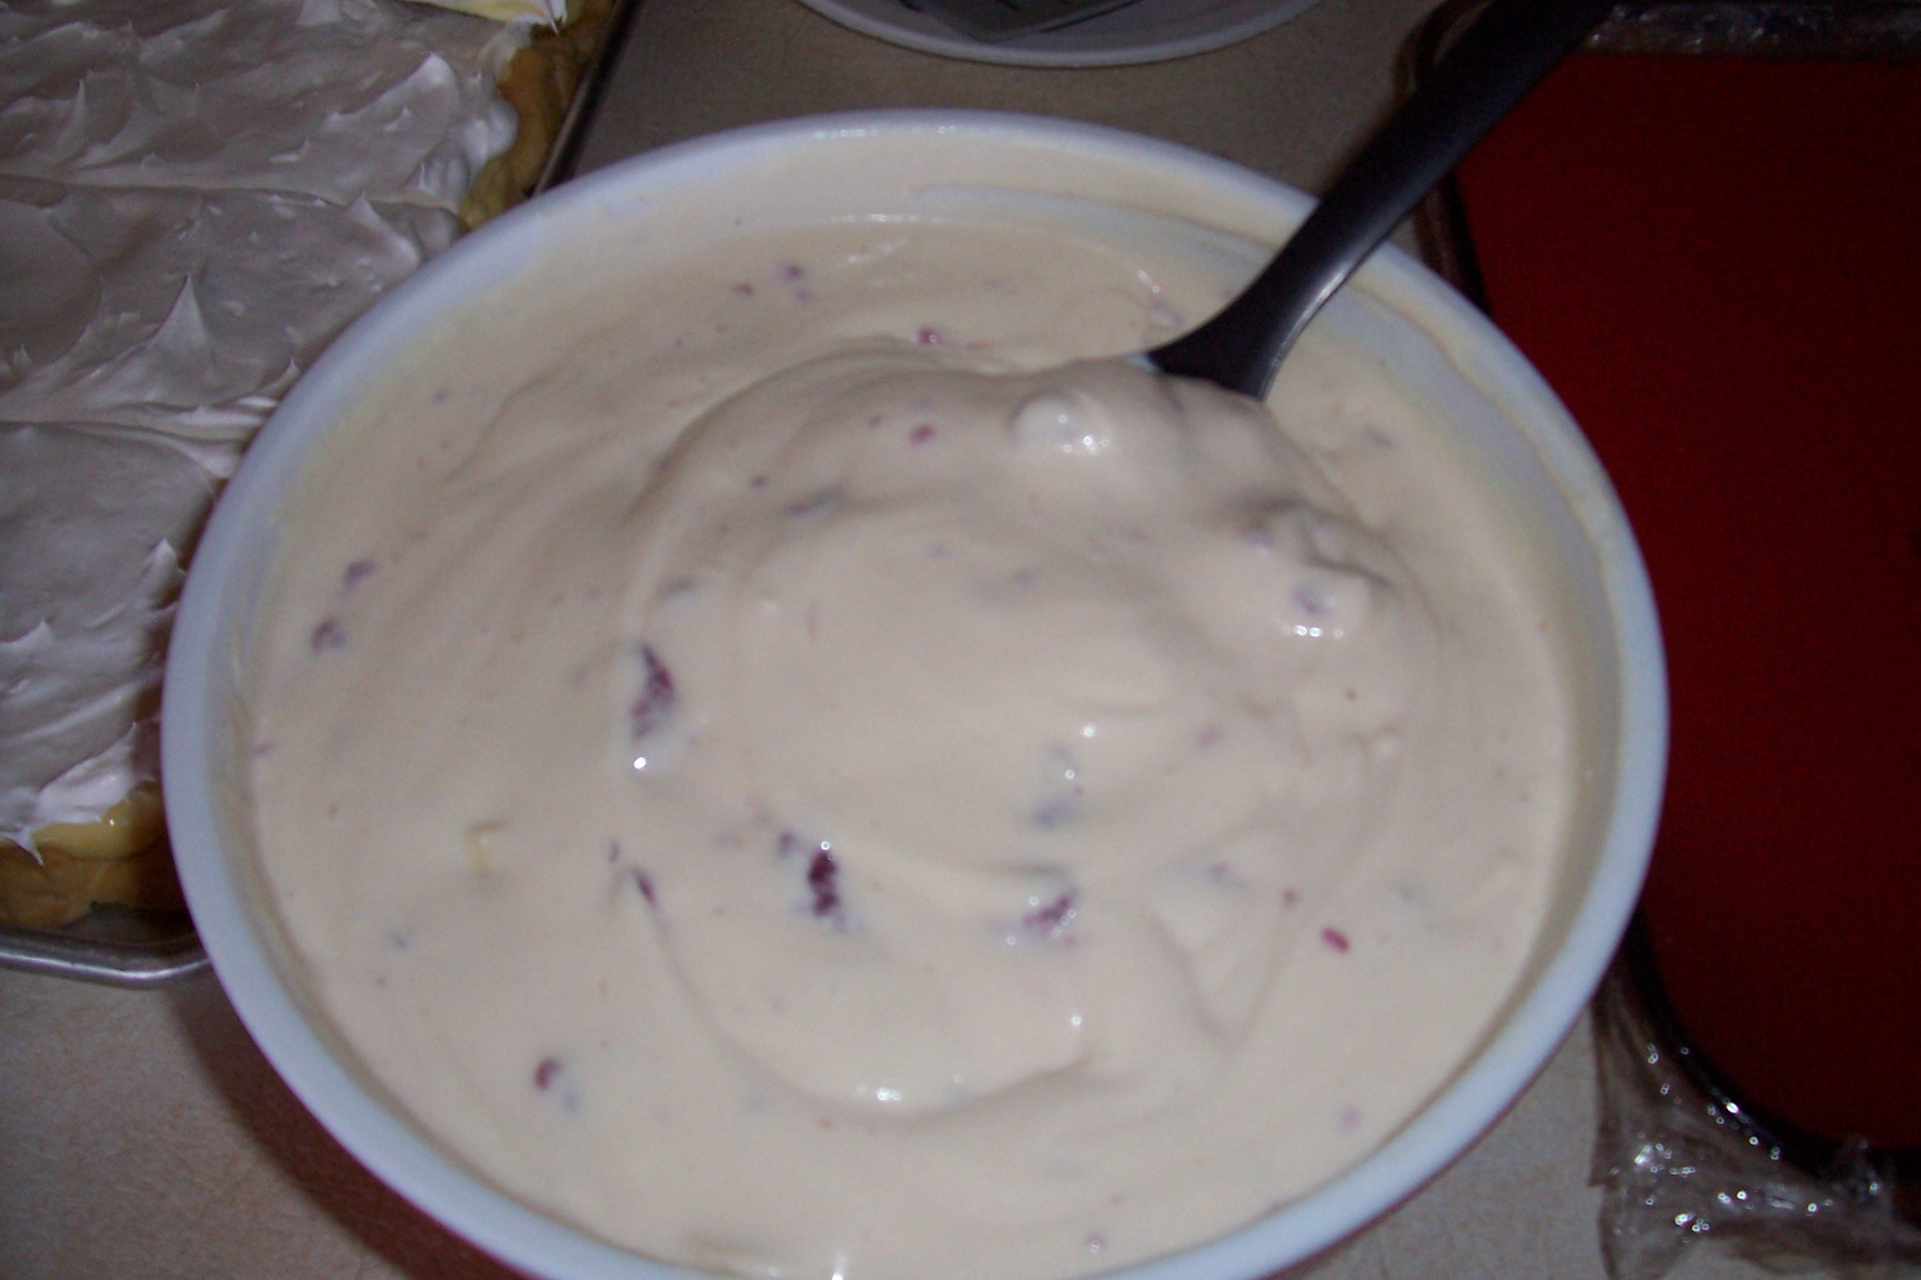
1 Large container of Vanilla Yogurt
1 Cool Whip
1 Box of Vanilla pudding
Bananas
Raspberries

Mix Yogurt and Cool whip together. Stir in dry Vanilla pudding. Add Bananas and raspberries. Chill and serve.

Pan Éclairs
Julie Garner
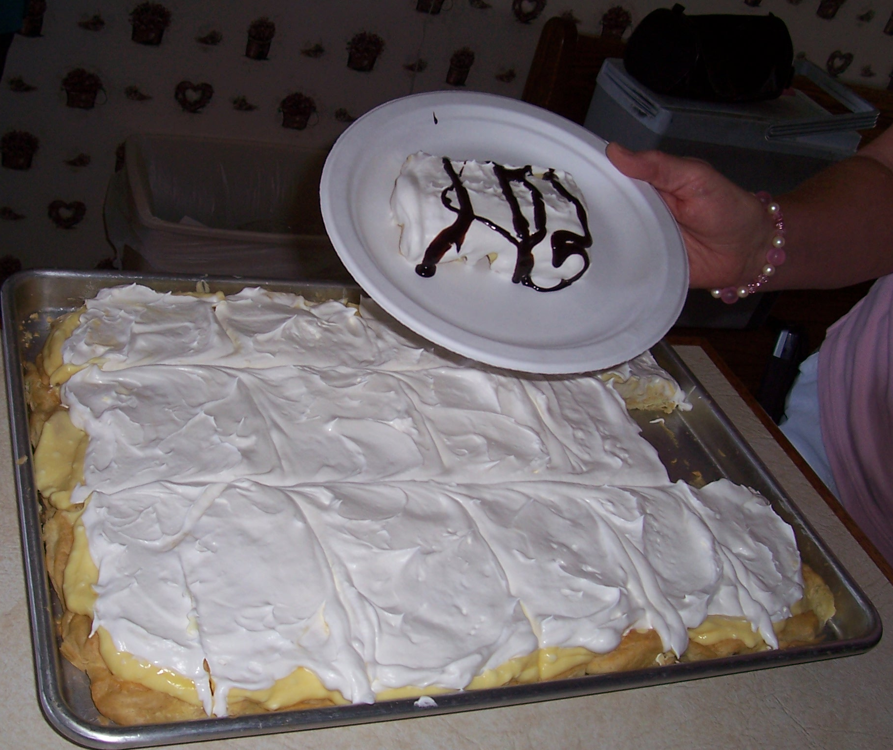
Boil 1 C. water and 1 Cube butter together.
Add 1 C. flour all at once
Stir until it leaves the side of the pan

Remove from heat and 4 eggs one at a time beating with mixer. Spread in 10 X 14 pan. Bake 20 min at 400 until golden brown. Cool

Topping:
2 lg pkg instant vanilla pudding
4½ C. milk
16 oz. softened cream cheese

Whip together and spread on crust. Top with cool whip. Drizzle with Hershey’s syrup

Taco Casserole?
Charmaine Harris




