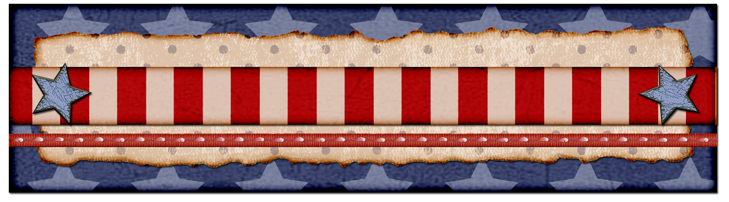

Crazy Tater Casserole
Shelley Pederson
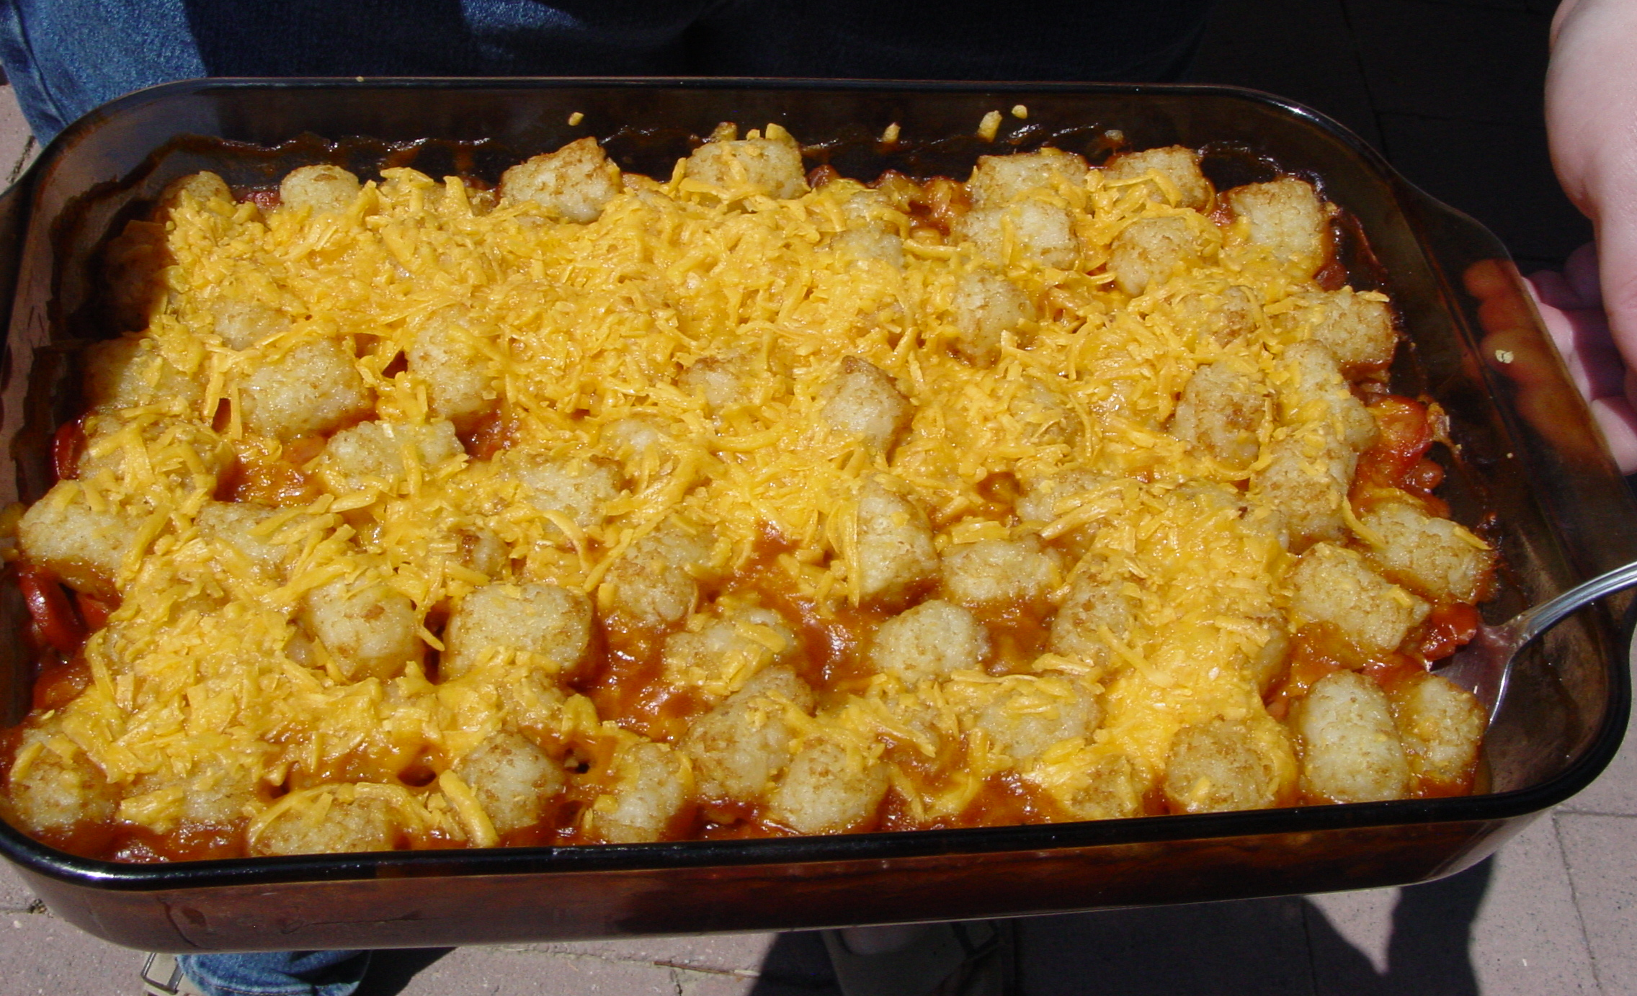
1 lb Ground Beef
Onion
1 Pkg Tater tots
1 lg can Cream of Mushroom soup
1 Can tomato soup
Cheddar Cheese shredded

Layer tater tots at the bottom of a 9 X 13 casserole dish. Put in oven to heat up tater tots. Brown ground beef and onion. Drain fat and add Mushroom and tomato soup. Pour hamburger mixture over the top of warmed tater tots and sprinkle with cheese. Bake until cheese is melted.

Zucchini Pizza Casserole
Rebecca Harris
Brown
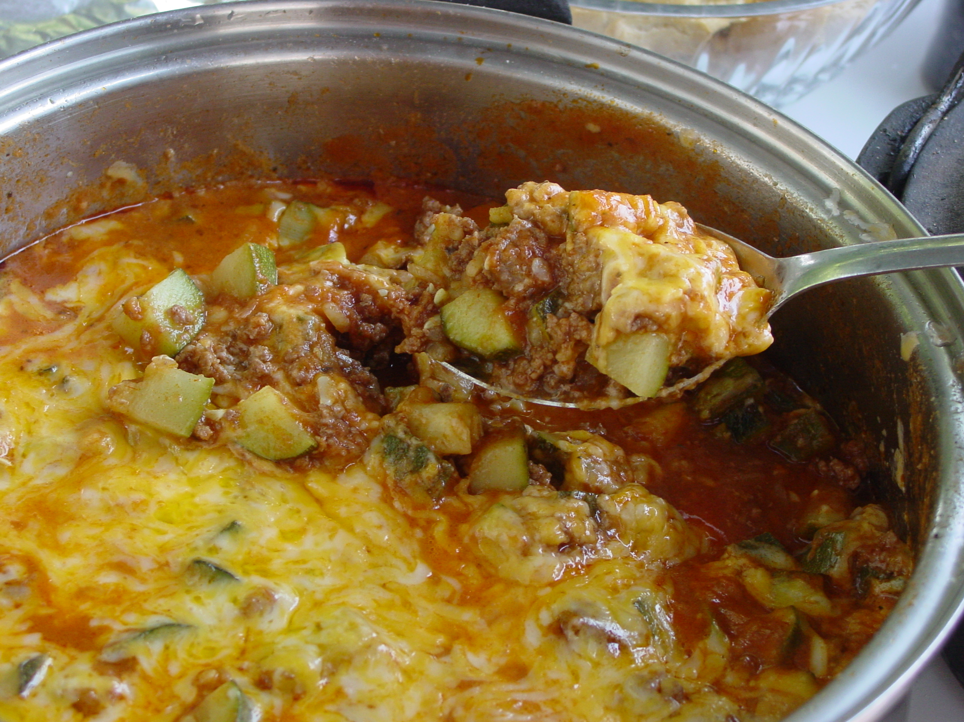
1 lb hamburger
Onion
Add:
2-3 med. zucchini’s cubed
1 Can Spaghetti sauce
Oregano
Salt and Pepper

Simmer until zucchini is tender. Add grated cheddar cheese and serve.
Easy Creamed Potatoes and Peas
Rebecca Harris
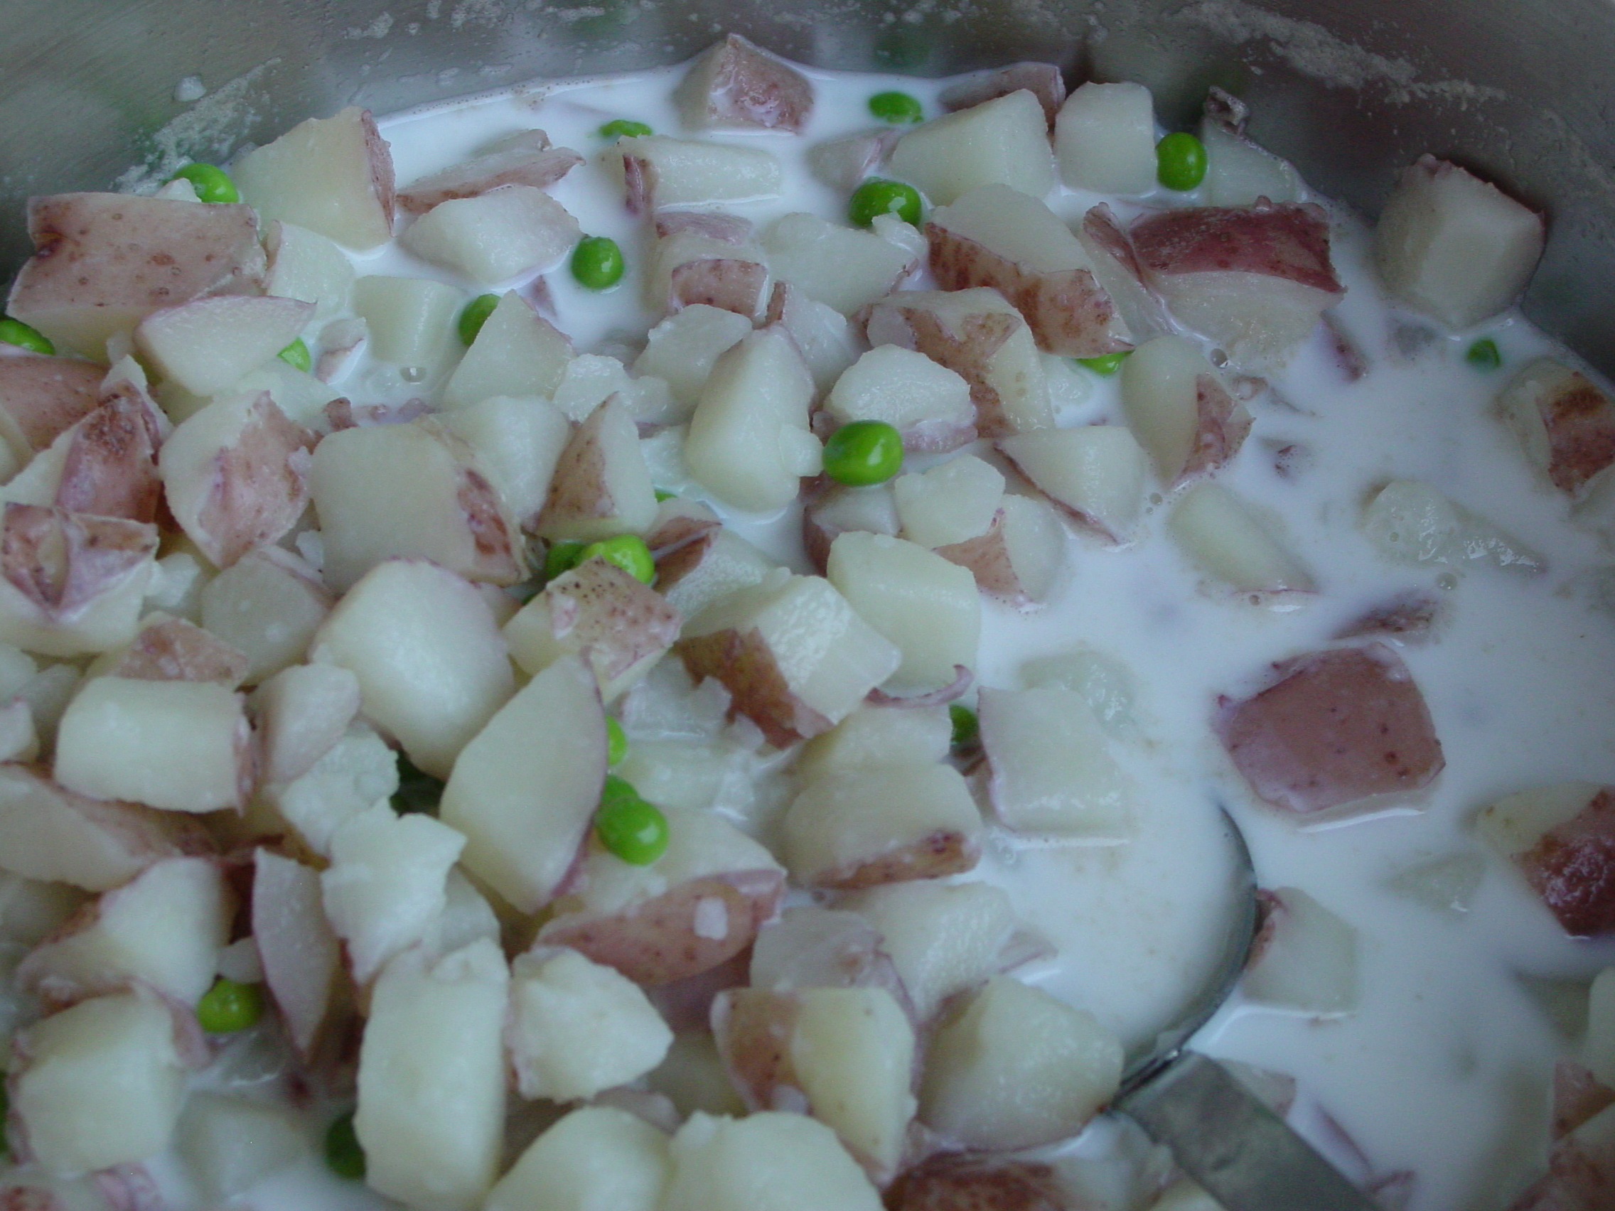
Red Potatoes
Fresh or frozen peas
Milk

Cut red potatoes into small chunks. Boil until tender. Drain water and add frozen peas and enough milk to not quite cover potatoes. Heat back up (do not boil with milk in it) and serve.

Chilled Shrimp and Stir Fry Vegetable Salad

½ bag Stir fry vegetables
1 C. salad shrimp
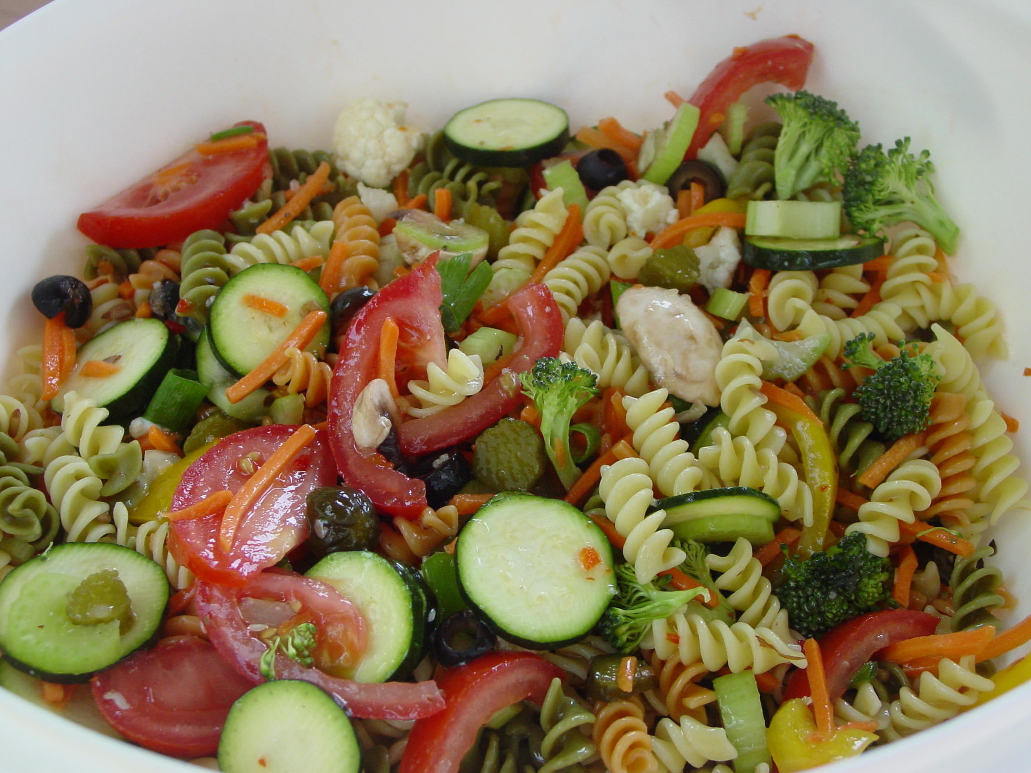
1 C. cooked angel hair pasta, cut in half
1 (8oz) can pineapple tidbits.

Dressing:
½ C Italian style dressing
2 t. soy sauce
1/8 t. garlic powder
1 T. pineapple juice or lemon juice
1 t. brown sugar
¼ t. Crushed red pepper or Tabasco sauce

Cook pasta according to package directions. Cool. Cook stir fry vegetables until just tender. Immediately rinse with cold water, strain and refrigerate to cool. Rinse shrimp in cold running water for 3 minutes and drain well. Place drained, chilled Stir Fry vegetables, shrimp, pineapple (optional) and cooked pasta in medium size bowl. Drizzle with dressing and toss to mix. Refrigerate before serving.
Frozen Salad

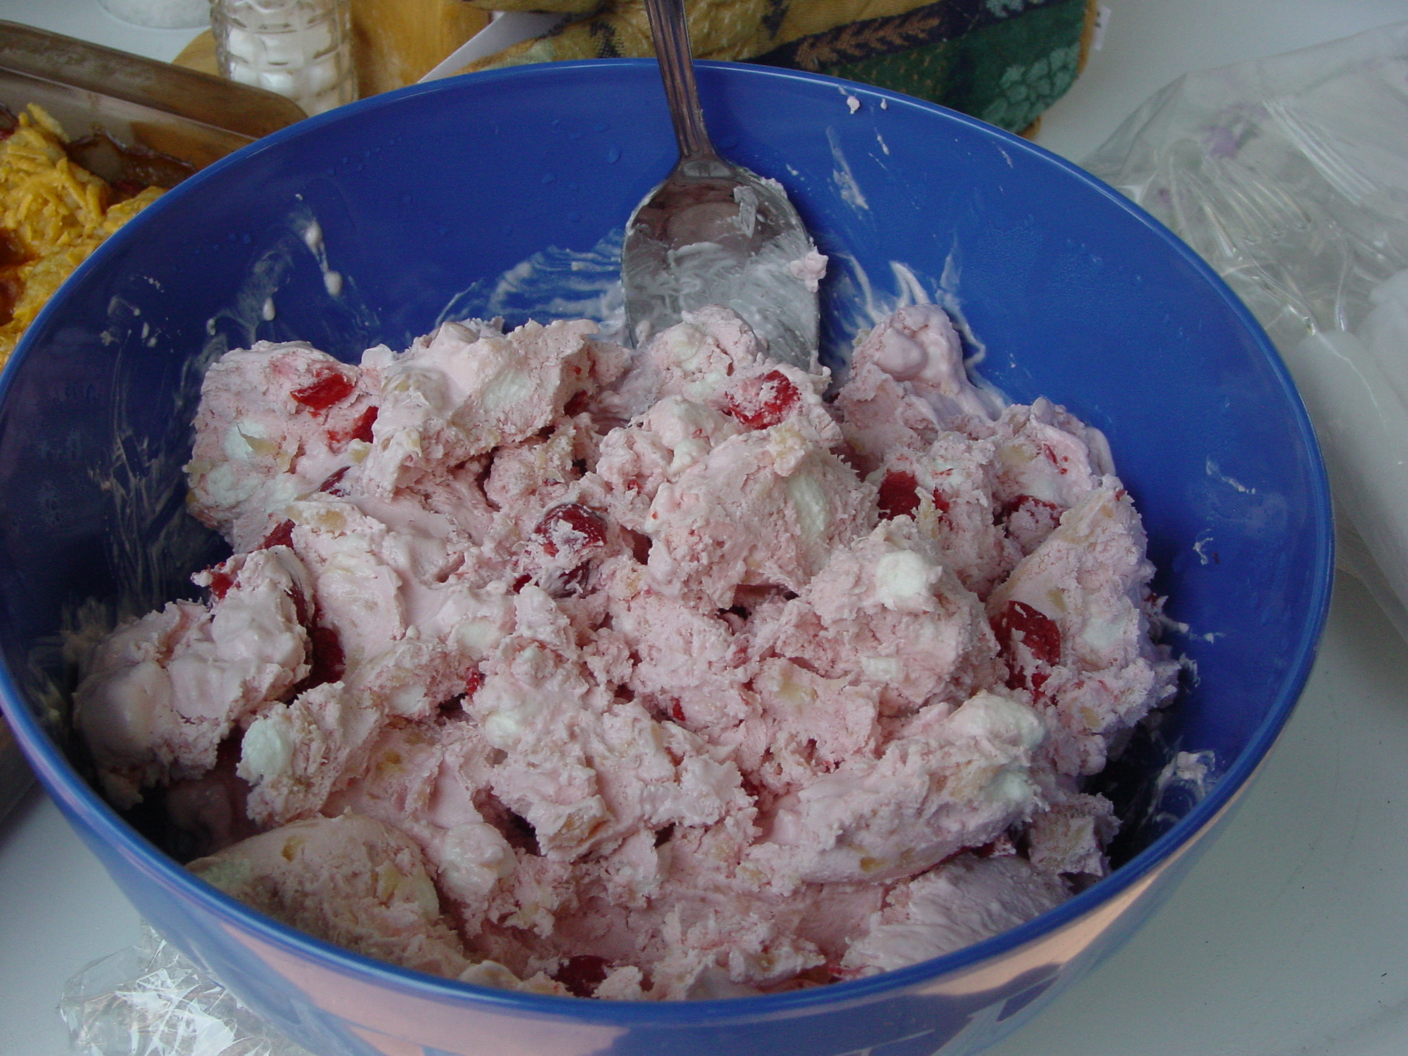
1 Can sweetened Condensed Milk
¼ C. Lemon Juice
1 Can Cherry Pie filling or 1 package partially thawed strawberries or raspberries
1 10 oz. can crushed pineapple drained
1 C. Miniature Marshmallows
12 oz. Cool whip
2 Bananas
½ Cup nuts

Mix all ingredients together in medium bowl. Pour into 13X9 in glass pan and freeze. Serve on lettuce leaves, or eat as is. Makes 15 (2 ½ in. squares) I freeze mine in a Tupperware bowl and scoop out servings.

Apple Pie Filling
Deanna Higens

Sliced apples
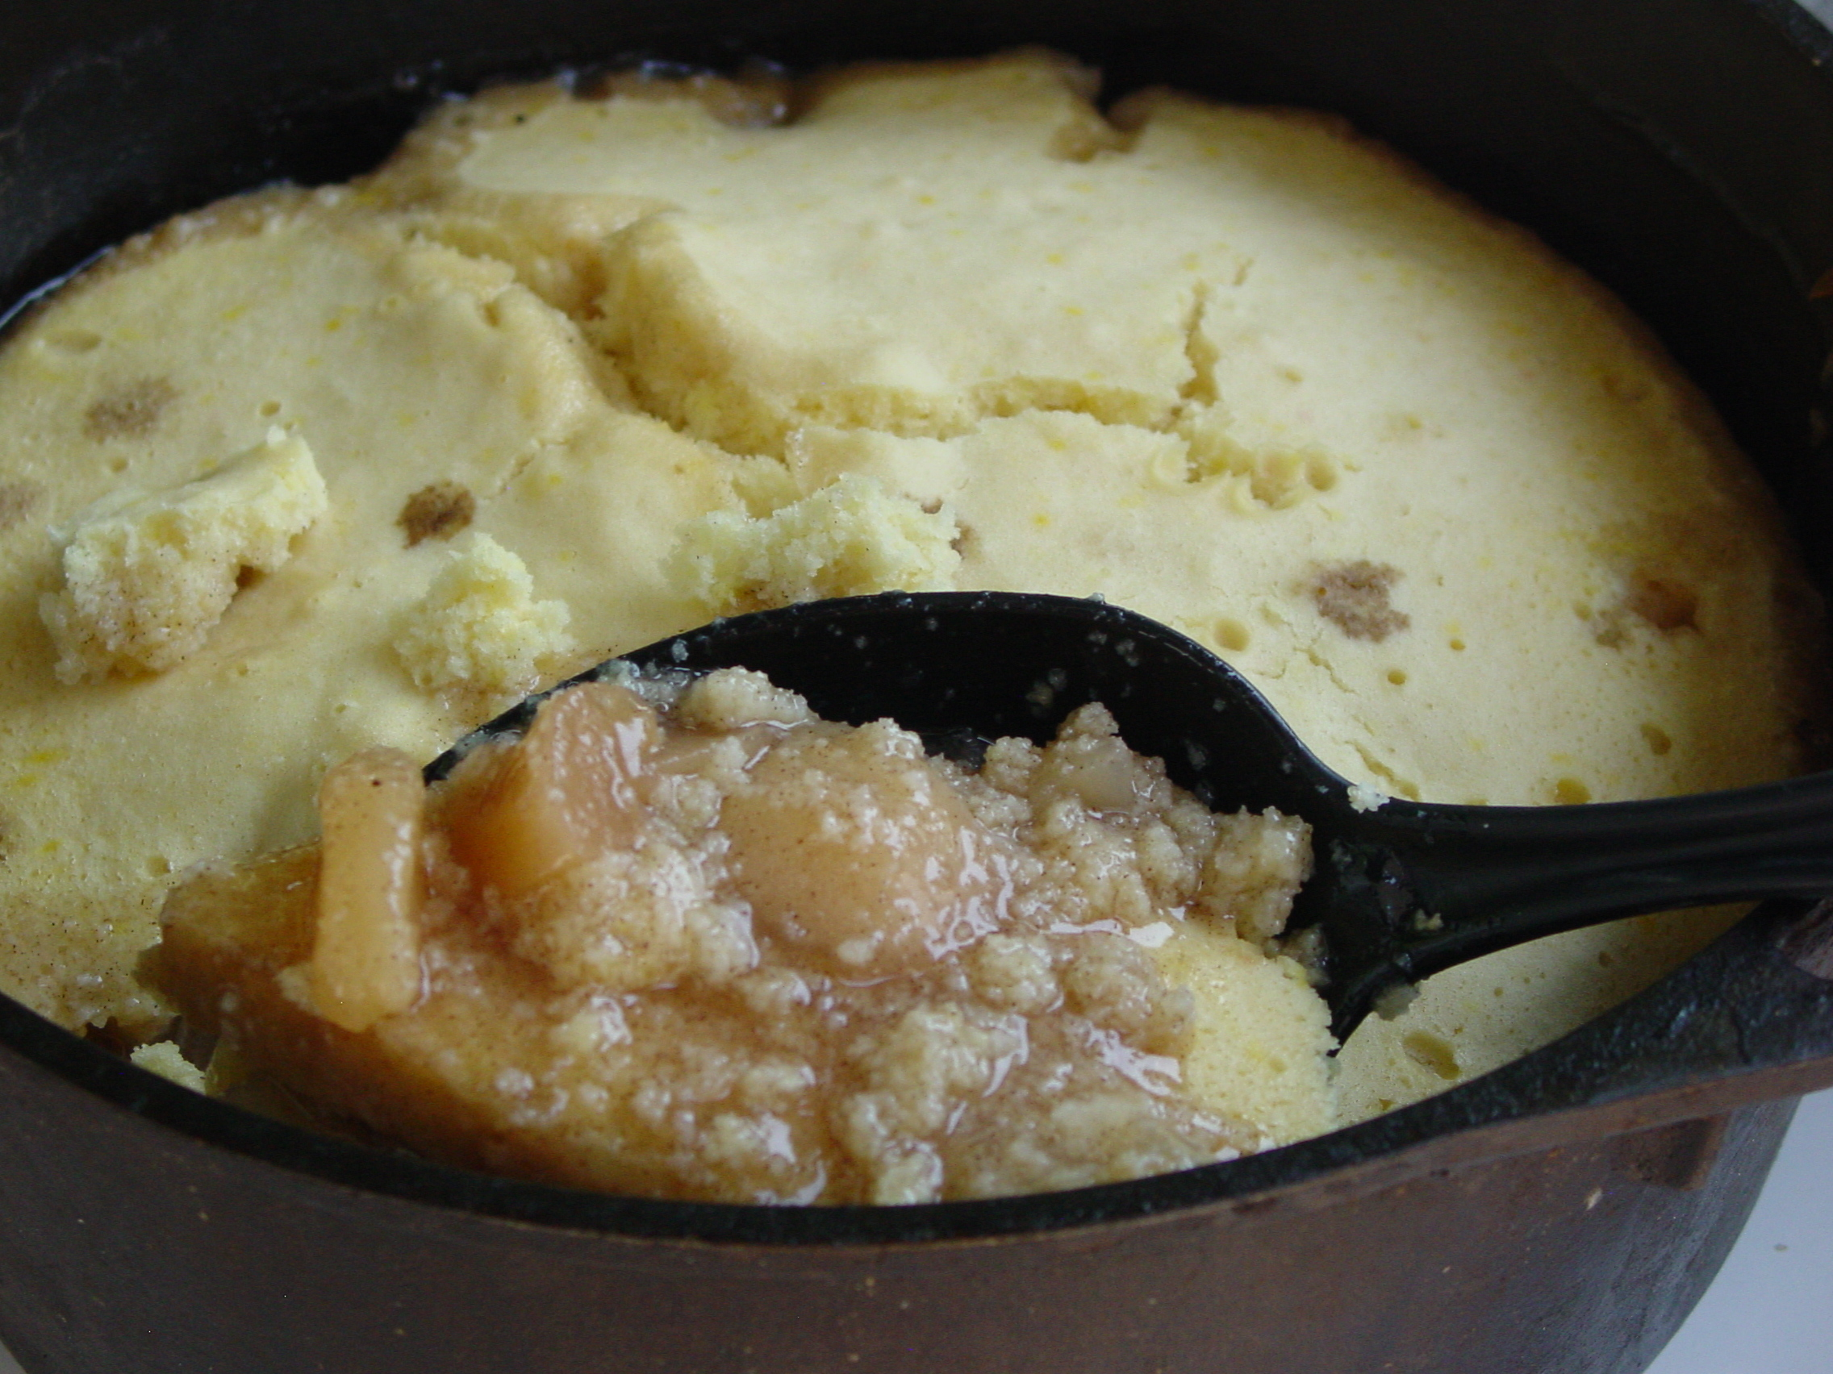
9 C. water
2 ½ C. sugar
1 C. cold water
¾ - 1 C. corn starch
2 t. cinnamon
1 t. almond extract
3 T. lemon juice
¼ t. nutmeg
¼ t. clove
¼ t. salt

Fill 7 quart jars with sliced apples.
Boil 9 C. water, sugar & spices. Dissolve corn starch in the 1 C. cold water. Add to the sugar mixture. Cook until clear and starting to thicken. Pour syrup over apples; fill to neck of jar. Wipe rims clean. Secure lids snugly. Process 35 minutes in boiling water bath.

Snicker Salad

Mix together & whisk:
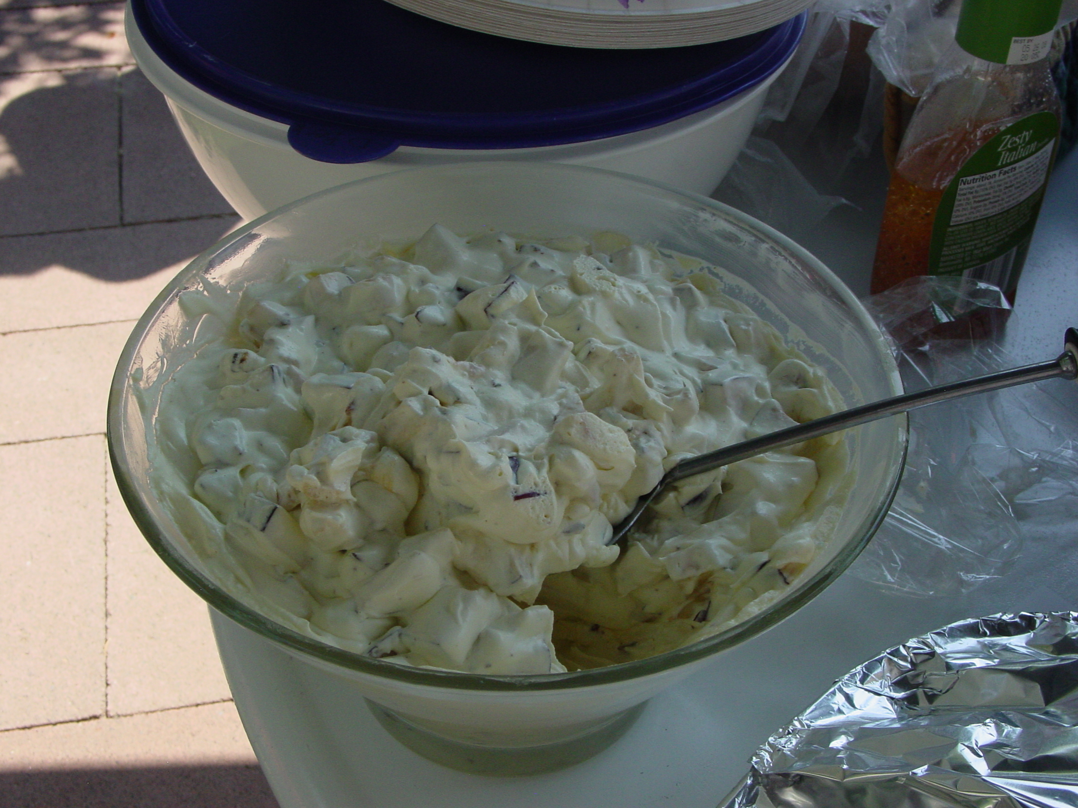
1 3oz. instant vanilla pudding
1 C. milk

Add:
1 8 oz. Cool whip or whipping cream
3 apples – cubed/ diced (bite size)
3 snickers bars, sliced

Stir all together.

Grandma Larson’s Dishpan Cookies
Dorothea Larson
Cream together:
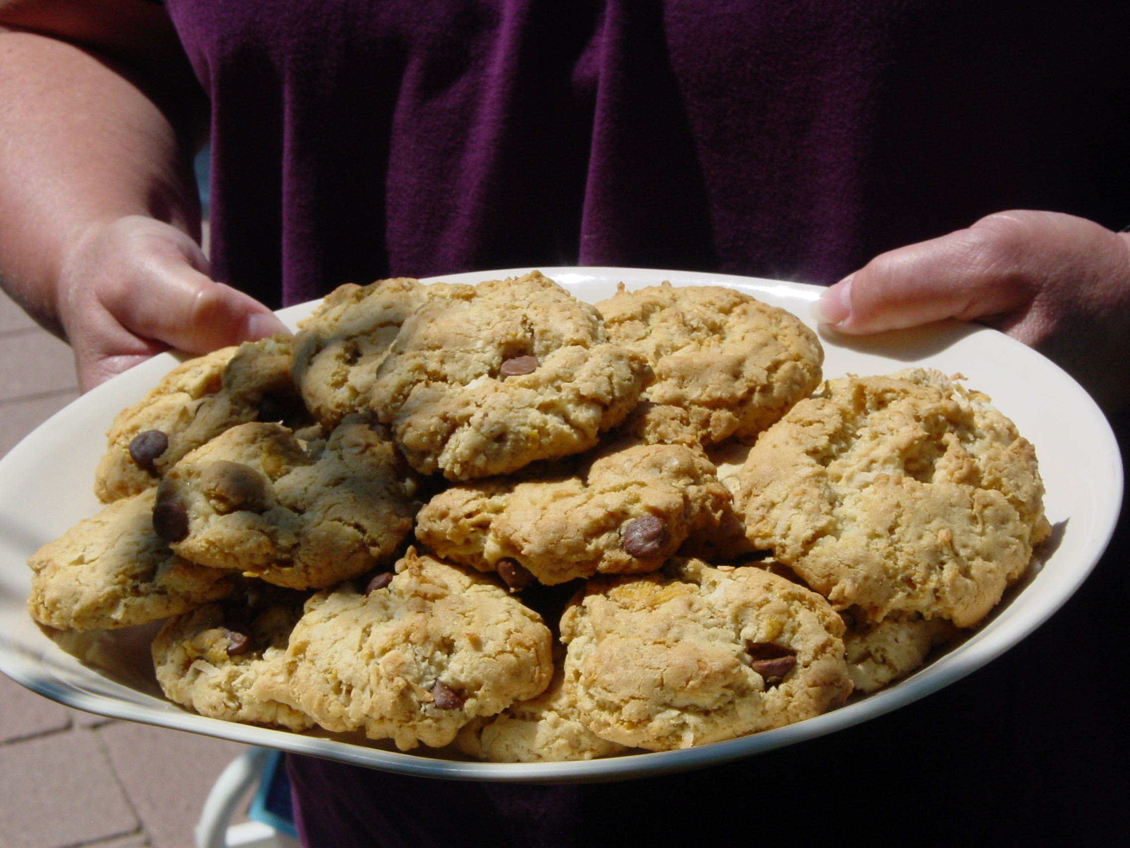
2 C. Sugar
2 C. brown sugar
2 C. oil
4 Eggs
2 t. vanilla

Add and mix well:
4 C. flour
2 t. baking powder
2 t. baking soda
1 t. salt

Stir in:
4 C. cornflakes
1½ C. oatmeal
1 C. coconut
1 C. nuts
1 C. chocolate chips

Drop on cookie sheet and bake 12 minutes at 350



