

Meat loaf Roll
Joleen Anderson
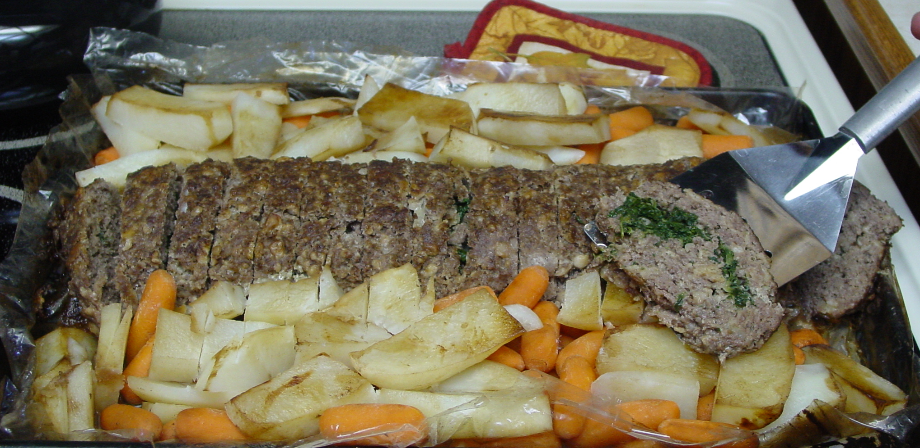
3 lbs of hamburger
4 eggs
1 package Lipton onion soup mix
1 tablespoon Worcestershire sauce
1 ½ packages of crushed crackers
knead and mix together

Line cookie sheet with wax paper pat or roll out meat mixture, until covers the pan. (You can use your own favorite meatloaf recipe.)
Take 16 ounces of thawed chopped spinach or broccoli and spread across center of rolled meat loaf staying about an inch and a half from edge, press down lightly. Roll like a jelly roll pulling wax paper away from edge as rolling, but keeping roll intact.
With wax paper holding roll together ease into turkey oven bag. Once it is in place remove wax paper and pinch off ends. Place potatoes and carrots along the edges. Season potatoes and carrots as desired.
Seal roasting bag and put slits in top of bag.
Cook for 45 minutes to an hour at 350° degrees. Side out of roasting bag on to platter and allow to cool for a few minutes, cut and serve.
A fun variety to this meatloaf roll is after it is rolled out line with thin slices of ham and then add vegetable and thin layer of cheese and roll.
For faster cooking, cook in large turkey type cooking bag.

Cream Cheese Chicken
Barbara Bean
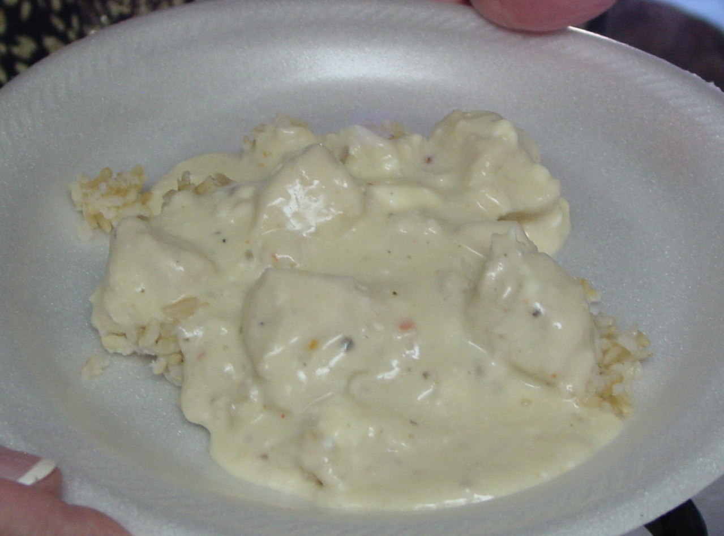

3 C. Cubed raw chicken
1pkg. Italian Salad Dressing
½ C. Water
1 8 oz pkg Cream Cheese
1 Can Cream of Chicken soup
1 Can Cream of Mushroom soup
¼ C. milk

Place chicken. Dry salad dressing mix, and water in crock pot. Cook on low for 4 hours. Then add all other ingredients. Cook another 20 minutes. Serve over rice or noodles.

Chicken Penny Alfredo
Rebecca Harris
4 Chicken breasts - cooked and cubed
1 pkg penny pasta - Cooked and drained

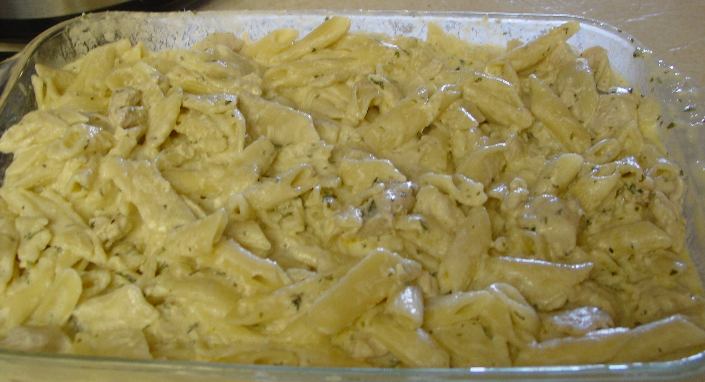
Melt together in separate pan
1 Cube butter
1 - 8 oz pkg cream cheese
1 ½ C. Parmesan cheese
Add:
2 C. Milk
3 T. parsley flakes
Garlic to taste
Salt & pepper
Top with Fried mushrooms (optional)

Heat until smooth. Sauce should not be thick. Add cubed chicken then mix with pasta. If it is too dry, add milk. Serve warm.

Carmel Apple Dip
Karen Whiting
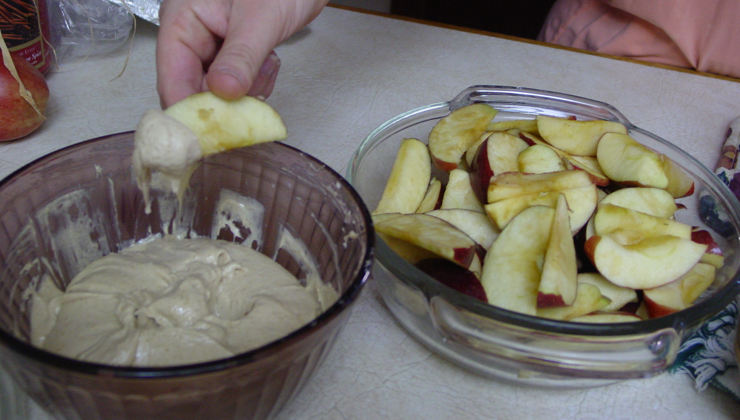
½ C. Powdered sugar
1 C Brown sugar
1 - 8 oz. Pkg. of Cream cheese
1/4 t. vanilla

Cream all ingredients together. Slice apples and dip in mixture.
Winter Fruit Salad
Deanna Higens
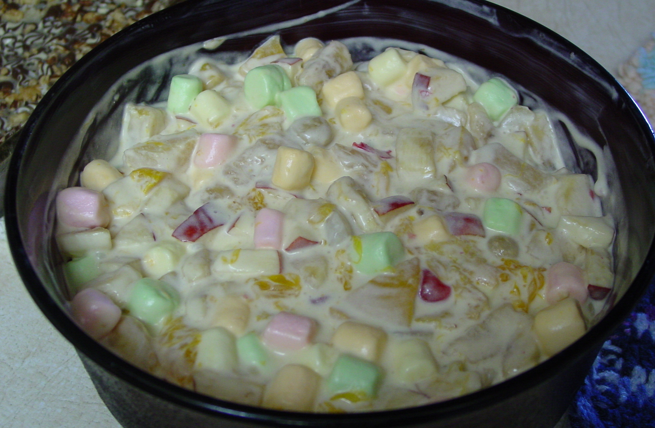
½ pkg. banana cream pudding
1 C. milk
1 C. Cool whip
1-2 Apples cut up
3 bananas cut
2 Cans Fruit Cocktail
1 Can Mondrian oranges
1 C. mini marshmallows
Nuts (opt.)

Mix together pudding, milk, and Cool Whip. Add fruit and stir together. Chill and serve

Double Layer Bars
Shelley Pederson

1 German Chocolate cake mix
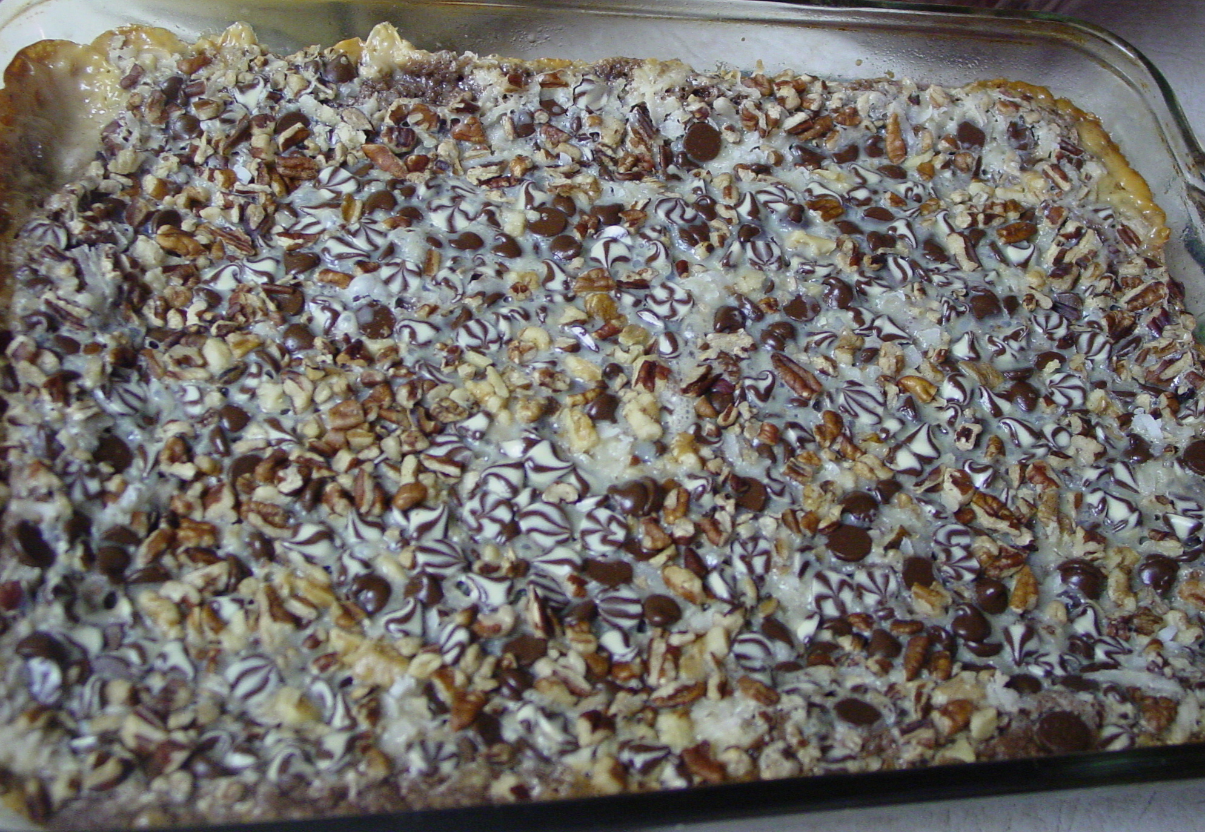
1 egg
½ C. melted margarine

Mix and press in 9X13 pan

Top with:
Sweetened condensed milk
Chocolate chips
Nuts
Coconut


Bake at 350° for 30 min.

