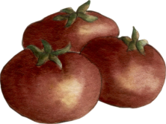
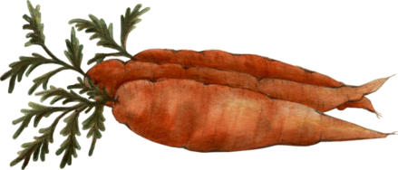
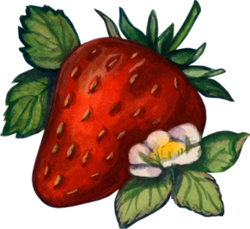
Healthy Snacks
Munch n’ Share
January 2012

Chicken Artichoke Cheese Dip
Amy Larson

1 (5 oz) can chunk chicken – drained & flaked
1 (14 oz) can artichoke hearts – drained & chopped
1 (.7 oz) package dry Italian salad dressing mix
1 (8 oz) container sour cream
1 cup Havarti cheese
¼ cup finely shredded Parmesan cheese
¼ cup sliced almonds
¼ cup mayonnaise

1) Preheat oven to 350 F
2) In a medium bowl, blend chicken, artichoke, Italian dressing mix, sour cream, ½ cup Havarti & Parmesan. Transfer to a small baking dish. Top with remaining Havarti & almonds. (Or, if you want, just mix all ingredients together, instead of saving some for the top.)
3) Bake 25 minutes or until bubbly and lightly browned.

Make Ahead Fruit Salad
Bonnie Jones
Mix A
Dice:
1 Pint strawberries
1 Large Banana
1 Red Delicious Apple
1 Can Pineapple Tidbits
1 Kiwi

Mix B
½ C. Fresh Lemon Juice
½ C. sugar
¼ t. Ground Nutmeg
¾ t. Cinnamon

Combine Mix A & B and Refrigerate.
*Note: You can change any of the fruits to suit your tastes. It is the juice mixture that makes a delicious and unique taste.

Fruit Crisp
Cindy Tolman
Crumble Mix:
5 C. Quick Oats
5 C. Packed Brown Sugar
5 C. Flour
2 t. Cinnamon
1 ½ t. Baking Powder
1 ½ t. Baking Soda
½ t. Salt

Combine ingredients. Store in an air-tight container.

To use: Place 1 can pie filling in 8 inch pan. Combine ¼ cup butter and 1 cup mix till crumbly. Sprinkle on top of filling. Bake at 350 for 30 to 40 minutes. Makes 6-8 servings per batch.

Fruit & Vegetable Smoothie
Rebecca Harris
2 C. Ice
1 C. Water
1 C. Milk
1 Handful of Spinach
8 Baby Carrots
½ Banana
1 to 1 ½ C. frozen fruit (I used ¾ C. Frozen berries & ¾ C. Frozen peaches)
¾ C. Strawberry Yogurt
1 pkg Emergen-C (Vit. C fizzy drink pack - I used Acai flavor)
1 Scoop vanilla whey protein

Blend until smooth. Serve immediately

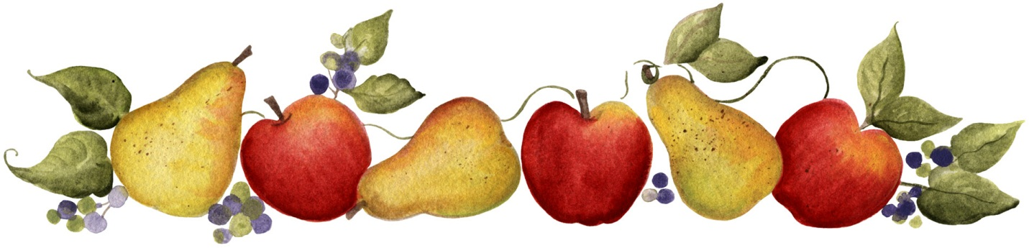
Many of the snacks didn’t come with recipes, and some weren’t healthy so recipes weren’t provided, but here are a few of healthy snacks that were brought:

