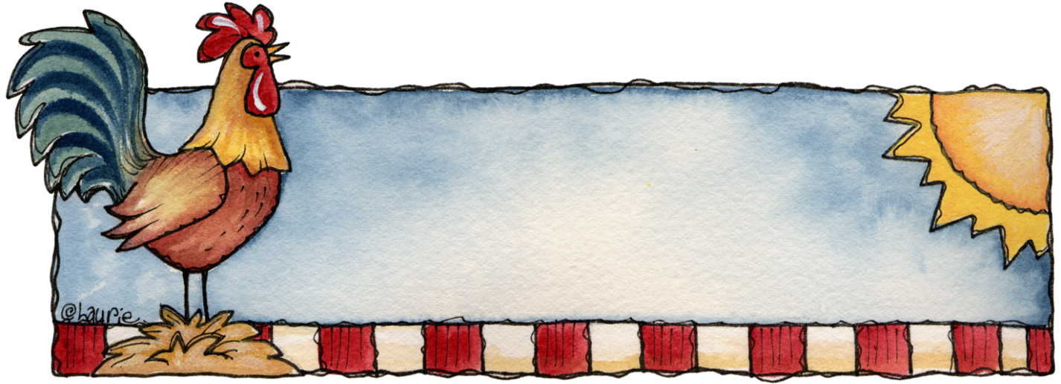
Star 2nd
August 2012

Munch n’ Share

King Ranch Chicken
Bonnie Jones
1 Onion
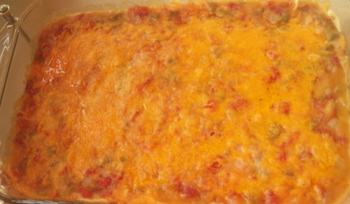
1 Green Pepper
¼ C. Butter
2 Cans Cream of Chicken Soup
2 Cans “Rotel” diced tomatoes & chilies
2 C. Cooked or canned chicken
6-12 Tortillas
1 lb. Grated Cheese

Chop and sauté onion, green pepper, and butter together. Add in the cream of chicken soup, “Rotel”, and the diced chicken. Heat the mixture until boiling. Tear the tortillas into smaller pieces. In a 9X13 pan or a crock pot, layer (like you would a lasagna) sauce, torn tortillas, cheese, sauce, torn tortillas, cheese, etc… You should have around 3 layers. Top with left over sauce and cheese. If you used a 9X13, heat in the oven at 350 for 30 minutes or until heated through and bubbly. If you used a crock pot, heat on high for an hour or until heated through and bubbly.
*Note: This is a large recipe. You can cut it in half for a smaller family.

Bubble Pizza
Karlene Bunn
1 Can Refrigerator biscuits
1 C. pizza sauce
½ C. Mozzarella cheese, grated
½ C. misc toppings (optional)

Cut up refrigerator biscuits into small pieces – about the size of a walnut, in a bowl. Combine all above ingredients using only ¼ of the cheese.
Grease or use non-stick spray in a casserole dish or a square cake pan. Spread the mixture into a thin layer. Cook for 30 minutes in a 350 preheated oven. The last 5 minutes, sprinkle the remaining cheese on top.
Cucumber Slices
Joanne Stradling
3 cucumbers
1 ½ - 2 C. Apple Cider Vinegar
¼ - ½ C. Lemon Juice
¼ C. Sugar
½ C. Water (optional – if you do not prefer a strong vinegar taste)
Pepper to taste
1 t. Dill, or to taste
Onion (optional) to taste

Combine all in a bowl and stir to dissolve sugar. Refrigerate at least one hour before serving. The longer it sits, the yummier.
*FYI – These are approximate measurements as I made this up and don’t measure it whenever I make it.

Zucchini Squash Bread
Janet Wright
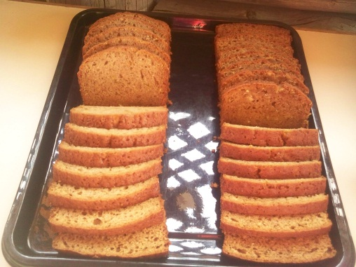
12 Eggs
4 C. Oil
8 C. Grated squash
12 C. Flour
7 C. Sugar
4 t. Salt
4 t. Soda
2 t. Baking Powder
8 t. Cinnamon
4 C. Nuts or raisins

Blend eggs, oil, and squash. Add remaining ingredients. Mix well.
Bake at 350 for 40-45 min.
Makes 5-6 loaves

Fruit Salad
Deanna Higens
1 Lag Container Yogurt – Vanilla or Plain
1 Small Vanilla Pudding, instant
1 Large Cook Whip

Mix together and add:
Frozen Fruit, Blueberries, Raspberries, etc.
Adjust size as desired.
Great Grandma’s Swedish Cake
Dorothea Larson
Simmer:
¾ C. Raisins in 1 Cup of hot water for 20 minutes
Cream:
¾ C. Sugar
½ C. Shortening
Add:
1 Beaten egg
Mix together and add to above:
1 ¾ C. Flour
½ t. Salt
1 t. Soda
½ t. Cinnamon
½ t. Allspice,
½ t. Nutmeg

Drain raisins, save ¾ C. raisin water (if not sufficient, add water).
Mix altogether and add 1 t. Vanilla
Bake at 350 for approximately 30 minutes in 7”X11” pan.

Casserole?
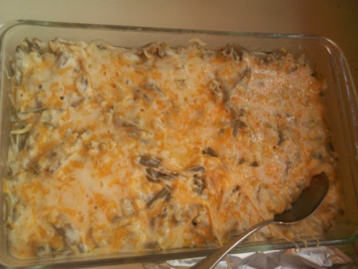
Viola Ricks?
3 C

Muffins?
Mary Jane Ricks?
3 C

Chocolate?
Amy Larson?
3 C. Water

