Munch n’ Share

Star 2nd January 2013

French Bread (Quick Rise)
Desiree Jensen
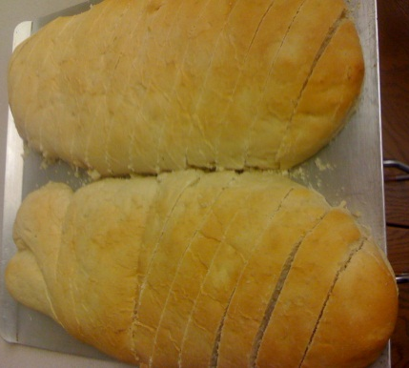
3 C. Water
3 T. Sugar
4 T. Yeast
Mix together until yeast is dissolved
Add:
1 T. Salt
½ C. Oil
8 C. Flour

Divide into 3 loaves and place on greased cookie sheet.
Let rise 15-30 min. or until it looks right. Bake at 350 for 20 min.

Taco Soup
Bonnie Jones
Cook together:
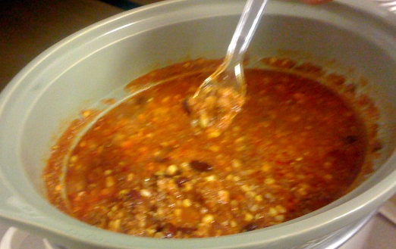
¼ C. chopped Onion
1 lb. of hamburger
Add:
1 package Taco mix
1 16 oz can tomatoes
1 16 oz. kidney beans with liquid
1 17 oz. corn with liquid OR frozen corn with 1 C. liquid
1 8 oz. can of tomato sauce
Boil for 15 minutes and stir

But corn chips on the bottom of your bowls, and pour soup over the top. Top with sourcream and shredded cheese.

White Chicken Chili
Cheyenne Harris
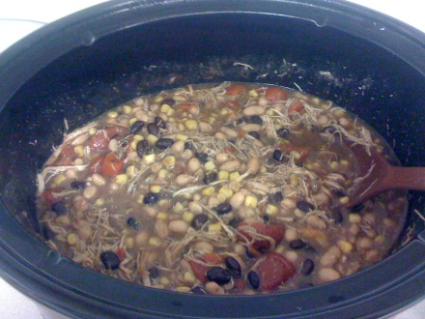
1 packet McCormick White Chicken Chili seasoning
2 Cans Great Northern beans, un-drained
1 Can Black beans, un-drained
1 Can Corn, un-drained
1 Can tomatoes, diced or stewed, un-drained
1-2 C. Cooked Chicken
½ C. Water

Simmer together 20 min. or cook in crockpot (low=6 hrs, high=3 hrs.)
Top with cheese, sour cream, avocado, etc.
Feeds 6-8

Meatballs
Julie Garner
1 lb. Ground beef
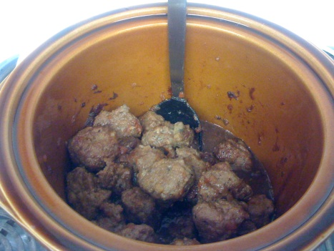
1 Egg
¼ C. milk
½ C. Bread crumbs
½ t. Salt
1 t. Oregano
½ t. Pepper (Fresh ground is best)
1 T. Fresh Parsley
Garlic powder to taste
½ C. Grated Parmesan cheese

Mix ingredients in large bowl by hand. Roll meatballs to desired size. Place on cookie sheet and bake at 350 for 25-30 minutes

Sauce:
1 14 oz Can Ocean Spray jelled or whole berry cranberry sauce
1 12 oz. bottle Heinz Chili Sauce

Combine in large saucepan. Cook over medium-low heat, stirring until smooth. Add meatballs. Cover and cook for 15 minutes or until meatballs are heated through, stirring occasionally. Or place meatballs in slow cooker and pour on sauce. Cover and cook on high.

Applesauce Muffins
Janet Wright
4 C. Flour
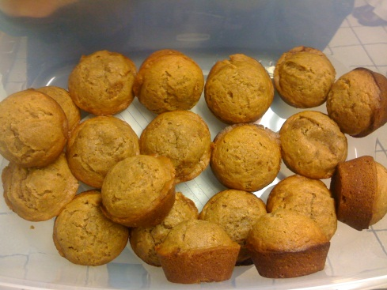
1 T. Cinnamon
1 T. All Spice
2 t. Baking Soda
1 C. Butter, softened
2 C. Sugar
2 Eggs
2 C. Applesauce
2 T. Vanilla
1 C. Raisins

Combine and put in muffin pan. Bake at 375 for 18-20 min.

Deviled Eggs
Amy Larson
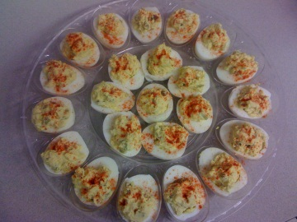
Hard boiled Eggs
Mustard
Mayonnaise
Dill Pickles
Paprika

Peel Hard boiled eggs and slice in half. Remove yoke and place in bowl. Place egg white halves on a plate. Mash yoke with a fork and add Mayonnaise, mustard and dill pickles to taste (If you don’t want the pickles in the mix, you can just use the pickle juice). Stir and re-fill egg halves. Sprinkle paprika on top.

Texas Brownies
Amy Larson

2 C. Flour
2 C. Sugar
1 Cube Butter
½ C. Shortening
1 C. Water
¼ C. Dark Unsweetened Cocoa
½ C. Buttermilk
2 Eggs
1 t. Baking Soda
1 t. Vanilla

In a large mixing bowl, combine the flour and sugar. In a heavy sauce pan, combine butter, shortening, water and cocoa. Stir until boiling. Pour boiling mixture over the flour and sugar in the bowl. Add the buttermilk, eggs, baking soda, and vanilla. Mix well. Pour into a well greased 17 ½ X 11” jelly roll pan. Bake at 400 for 30 min. or until done in the middle. While brownies bake, prepare the frosting.
(*Buttermilk substitute – Add 1 T. lemon juice or vinegar to milk and let set for 5 min.)

Frosting:

½ C. Butter
2 T. Dark Cocoa
¼ C. Milk
3 ½ C. un-sifted powdered sugar
1 t. Vanilla

In a saucepan, combine butter, cocoa, and milk. Heat to boiling, stirring constantly. Mix in the powdered sugar and vanilla until frosting is smooth. Pour warm frosting over brownies as soon as you take them out of the oven. Cool

Impossible Peach Cobbler
Charmaine Harris
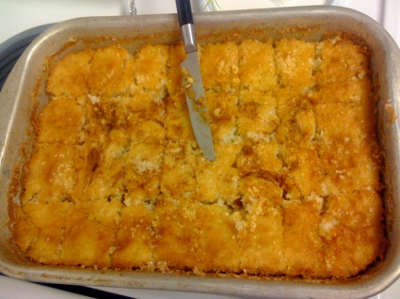
1 Cube Butter
1 ½ C. Sugar
2 C. Flour
3 t. Baking Powder
1 ½ C. Milk
Canned peaches

Melt butter in 9X13 pan while oven is heating. Mix ingredients and poor over milted butter. Dot with bottled peaches. Bake at 350 for 30-40 minutes.

Carmel Apple Dip
Viola Ricks
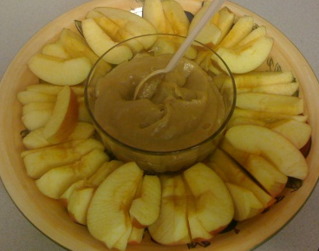
8 oz. Cream Cheese
½ C. Brown Sugar
1 t. Vanilla
Soften cream cheese and add brown sugar and vanilla. Stir & serve

Peanut Butter Hummus
Joanne Stradling
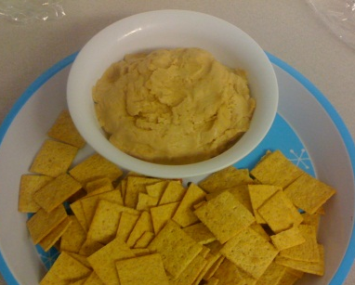
¼ C. Canola or Olive oil
½ C. Peanut butter
1 Can (16 oz) Chick peas (or equivalent of dried)
3 T. Lemon or lime juice
1 T. Dark sesame oil
1 Clove Garlic
¼ t. salt

Combine all into a food processor or blender and blend until smooth. Serve.
