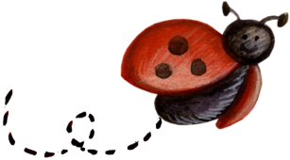

Munch n’ Share

Star 2nd Summer Salads & Desserts May 2013

Spinach Salad with Poppy Seed Dressing
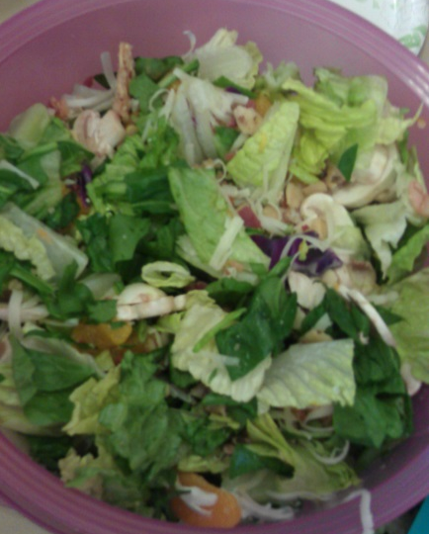
Desiree Jensen
Salad
Lettuce and Spinach
1 Can Mandarin oranges, drained
Sliced Mushrooms
Bacon Bits
Swiss cheese
Buttered Almonds (see below)

Poppy Seed Dressing:
½ C. White Vinegar
½ C. Sugar
2 T. Poppy Seeds
1 T. Regular Mustard
1 T. Grated onion (small grate)
½ t. Salt
1 C. Oil

Blend all but oil together. Slowly add oil.

Buttered Almonds
¼ C. Almond slices
1 ½ T. Sugar
1 T. Melted butter

Blend Sugar and Butter. Coat almonds and spread on tinfoil lined baking sheet. Bake at 350 for 10-15 min. or until lightly browned, but not dark. Let cool completely.

Spinach Strawberry Salad
Viola Ricks
Baby Spinach
Iceberg Lettuce or any mix of greens
Sliced Strawberries
Sliced Almonds
Craisins

Serve with Strawberry Yogurt as dressing.

Pasta Salad
Monica Koyle
4 C. Uncooked Pasta
1 Can Corn
1 Can Carrots
1 Can Whole Olives
Cooked Shrimp
Mayonnaise
Spices to taste

Cook pasta, then rinse with cold water and drain. Combine the rest of the ingredients and refrigerate.

Broccoli Salad
Julie Garner
4 C. Chopped Broccoli
¾ C. Mayonnaise
2 T. Vinegar
¼ C. Sugar
½ C. Red or Green onions (I use less)
½ C. Grated Cheese
Raisins or Craisins (optional)

Mix together and refrigerate a few Hours.

Fiesta Bean Salad
Rebecca Harris
1 Can (15 oz.) Red Beans
1 Can Black Beans
1 Can Kidney Beans
1 Can Corn
1 Can Olives, chopped
1 Can Diced tomatoes with Chilies
½ to 1 Onion, chopped
2 T. Lime Juice
1 T. Lemon Juice
Cilantro to taste
Southwest or Mexican seasoning to taste
Salt & Pepper to Taste

Combine all ingredients and let set in fridge for a couple of hours or overnight to let flavors marinate together. Serve over tortilla chips.

Jell-O Pudding Fruit Salad
Kimberlee Harris
1 (3 oz.) pkg. Tapioca Cook & Serve Pudding
1 (3 oz.) pkg. Vanilla Cook & Serve Pudding
1 (3 oz.) pkg. Jell-O Gelatin (Flavor to match fruit)
3 C. Water
1 (8 oz.) Container of Cool Whip
½ lb. Fruit

Combine Puddings, gelatin, & Water in a medium pot. Bring to a boil and then pour into a casserole dish & refrigerate over night. Next day, mix cool ship & fruit. Stir until smooth. Enjoy!

Rhubarb Crunch
Amy Larson
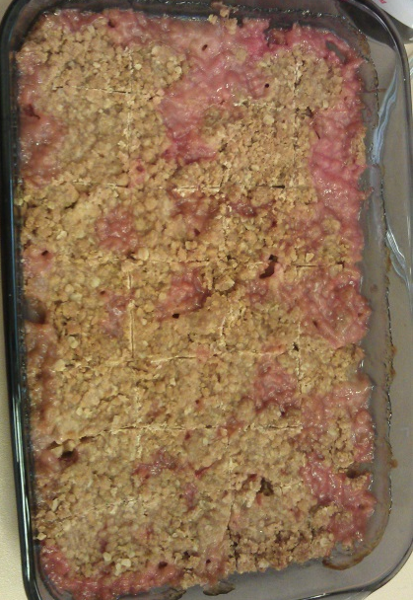
4 cups diced rhubarb – spread evenly in 9 x 13 pan

Thickening:
¾ C sugar
Cook on Medium heat in saucepan until clear & thick; then pour over rhubarb.
}
2 Tbsp. Corn Starch
1 C Water
½ tsp. vanilla

Topping:
Combine together with hands until it is all little crumbles. Sprinkle over rhubarb.
}

1 C flour
¾ C Oatmeal
1 C Brown Sugar
1 tsp. cinnamon
½ melted butter

Bake in 350 Oven for 40 t0 50 minutes.

Congo Bars
Deanna Higens
2 1/2 cubes margarine
2 cups brown sugar
2 cups sugar
6 eggs
2 tsp vanilla
1 tsp salt
Mix together well

Add
4 cups flour
1 Tbls baking powder
2 cups chocolate chips

Pour into a jelly roll pan. Bake for 30 minutes. Cool and cut
Orange Salad
Mary Jane Ricks
1 Small Cottage Cheese
1 Small Orange Jell-O
1 Small Cool Whip
1 (11 oz.) Mandarin Oranges

Mix together & Refrigerate until set.

Fruit Pistachio Dessert
Janet Wright
1 (16 oz.) Container Whipped Topping
1 C. Miniature Marshmallows
1 (6 oz.) pkg. Instant Pistachio pudding mix
1 (16 oz.) Can Crushed Pineapple
½ C. Chopped Nuts

In a large bowl, stir whipped topping until smooth. Add marshmallows and pudding mix. Stir in pineapple with juice and nuts. Refrigerate at least 1 hour.
Serves 5-6

Rhubarb Slab Pie
Joanne Stradling
3 ¼ C. Flour
1 C. Butter
1 Egg yolk
1 t. Salt
¾ C. Milk plus 1-2 T.

10 C. Chopped Rhubarb
2 ½ C. Sugar
10 T. Flour

Mix flour & salt. Cut in butter. Combine egg yolk & ¾ C. Milk; add to flour mixture with a fork until all is moistened. Add 1-2 T. milk as needed. Divide into 2 balls; one slightly larger than the other. Roll out larger ball to fit 15X10 pan. Press up & a little over sides. Combine rhubarb with sugar & 10 T. flour and add to pan. Roll top crust to fit. Fold bottom crust over top then seal and brick top. Bake at 375 for 45-55 min. Top with glaze or before baking, brush with milk & sugar.

