Star 2nd Valentine Treats Feb 2014

Heart Peanut Butter Cups
Kimberlee Harris
Blend Together:
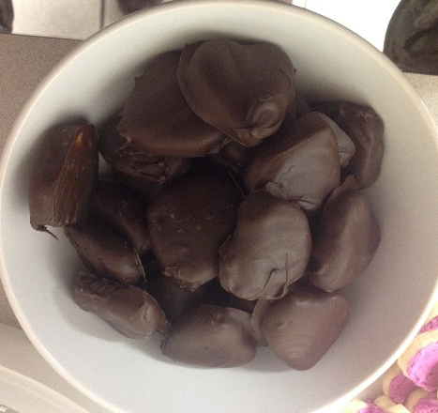
2 C. Powdered Sugar
1 Stick (½ C.) Butter or Margarine
1 C. Peanut Butter

Melt:
Dipping Chocolate or Chocolate Chips.

Form peanut butter cups in miniature cupcake papers.
Layer peanut butter mixture then chocolate in the cups that are in a pan.
Or
Roll balls and dip in chocolate for peanut butter balls.

Rice Krispie Kisses
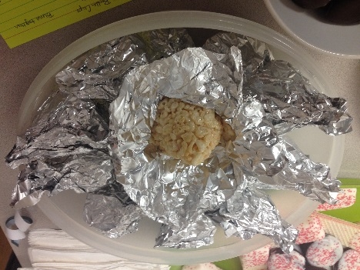
3-5 T. Butter or Margarine
1 bag marshmallows OR 4 C. miniature marshmallows
6 cups Rice Krispies (10-12 C.)

Melt margarine & add marshmallows. Stir until melted. Add Rice Krispies. Form into kiss shape and wrap in foil.

Sugar Cookie Hearts
Monica Koyle
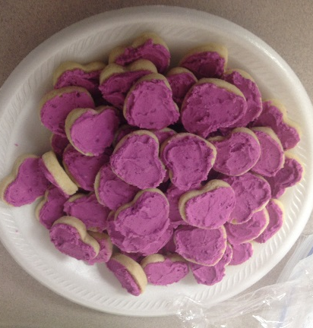
Cream together
1 ¼ Cup Butter (Best if you use real butter)
2 Cups sugar
2 eggs

Add:
5 Cups flour
1 teaspoon salt
4 teaspoons baking powder
1/2 Cup milk

Mix together. Roll out and cut into shapes. Bake at 375° for ten minutes. Cool and frost.
The Most Famous Whole Wheat Chocolate Chip Cookies on Earth

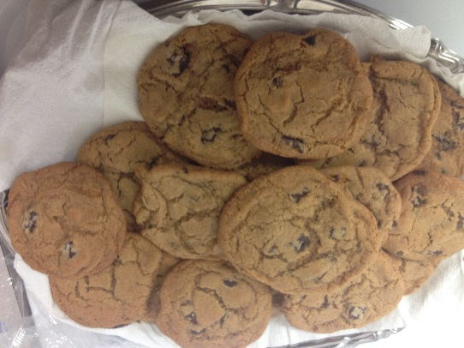
8 oz (2 sticks) room temperature butter
1 C. Brown Sugar (preferably dark)
1 C. White Sugar
2 Eggs
2 t. Pure vanilla extract
3 C. Whole Wheat Flour
1 ½ t. baking powder
1 ½ t. Salt
8 oz Dark Chocolate bar roughly chipped into ¼ - ½ pieces or 1 bag dark chocolate chips

Sift dry ingredients into a large bowl and set aside
Put butter in mixer bowl with dough hook or paddle attachment (do not melt)
Add the sugars and blend just until blended on low.
Mix in vanilla
Add flour mixture to the bowl and blend on low speed just until the flour is barley combined – about 30 sec.
Add the chocolate all at once. Mix on low speed until the chocolate is evenly combined. If you need to use your hands to fully incorporate all the ingredients.
Scoop mounds of dough (about 3 tablespoons) onto a baking sheet lined with parchment paper. Fill two baking sheets . Leave 3 inches between them or about 6 to a sheet.
Bake cookies 14-16 minutes (one on top rack and other lower rack) rotating sheets half-way through
Transfer cookies, still on parchment, to the counter to cool and repeat with remaining dough.

These cookies are best eaten warm or later the same day. They will keep in an airtight container for about 3 days.
(Makes 20 large cookies)

White Chocolate Dipped Cookies
Desiree Jensen
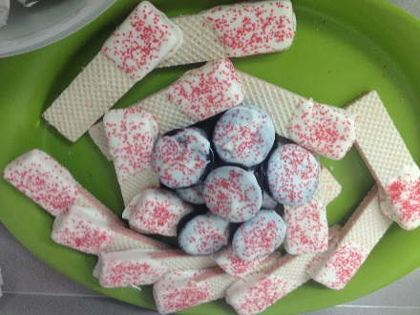
Melt White chocolate in a double boiler.
Dip cookies in melted chocolate
Sprinkle with colored sugar.
Let cool and serve.

