Star 2nd Home Storage Sept 2014

Munch ‘n Share

Shepherd’s Pie
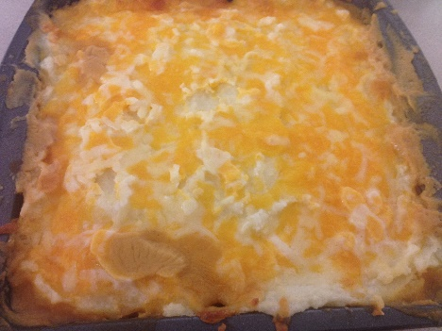
1 pkg. Mashed Potatoes (instant)
1 lb. Ground Beef or Ground Turkey
1 Can Corn
1 Can Beans
1 Can Cream of Chicken Soup
1 C. Grated Cheese

Heat oven to 350° F.
Brown beef, and drain fat. Mix with soup, beans, and corn. Put this mixture in the oven to heat. Mix mashed potatoes. Then place layer over meat and veggie mix. Sprinkle with cheese. Heat in oven for 20 minutes.

Spaghetti Salad
Bonnie Jones
1 lb. Spaghetti – break and cook in boiling water, and drain.
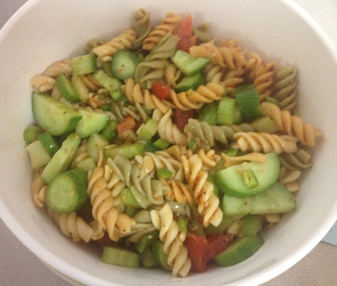
-Pour over
8 Oz. Kraft Italian Dressing
½ bottle (2.6 oz.) Salad Supreme
- Refrigerate and then add cut up vegetables
1 Large Green Pepper
1 Large Green Onion
2 Cucumbers
2 Celery Stalks
2 Tomatoes

Pumpkin Muffins

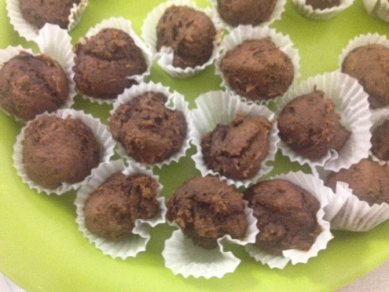
1 Box Cake Mix
1 15 Oz. Can Pumpkin puree
Chocolate Chips (optional)

Combine ingredients. Bake at 350° F
13 minutes for mini muffins
20 – 25 minutes regular muffins

Coconut Lime Zucchini Bread

BREAD:

3 eggs
¾ C oil
1 ½ C sugar
2 t lime zest
1 t lime juice
1 t coconut extract
2 C shredded zucchini, skin on or off
2 ½ C flour
2 t baking powder
¾ t salt
¼ t soda
¾ C coconut, sweetened and flaked

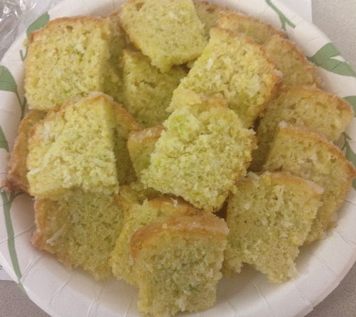
GLAZE:
½ C sugar
2 T lime juice
½ t coconut extract

1. Preheat your oven to 350°.
2. Into a large mixing bowl or stand mixer place 3 eggs, 3/4 cup oil and 1 1/2 C sugar. Beat the mixture together until well combined.
3. Add 2 teaspoons lime zest, 1 teaspoon lime juice and 1 teaspoon coconut extract.
4. Find a nice zucchini. Wash it and shred it up. I opted to leave the peel on, thought it might look kind of pretty. :) You need 2 cups total, toss it into the bowl and give it a stir to combine.
5. Into a medium-sized mixing bowl add 2 1/2 cup flour, 2 teaspoons baking powder, 3/4 teaspoon salt and 1/4 teaspoon soda. Toss them around a bit with a fork to make sure everything is well combined. Add it to the wet mixture.
6. Add 3/4 cup coconut to the bowl.
7. Mix it together, just until all of the flour has been incorporated. You don't want to over mix, alright? It will give you a dry bread.
8. Take some parchment paper (or wax paper) are draw the bottom of your pans onto it. Cut the paper out and line the bottom of the pans with it. Then spray them generously with cooking spray with flour added. I love this Bakers Joy, you can also find Pam spray with flour as well.
9. I ended up using a large loaf pan (9 1/2 x 5 1/2) and two small loaf pans (4 1/2 x 3 1/2). There wasn't quit enough batter for 2 large pans. However, the small pans ended up working better than the large pan. The little slices had more glaze. :) Next time, I believe I will opt for small pans all around.
10. Bake for 20-25 minutes for the small pans, and 35-45 minutes for the large pan.
11. While the loaves are still hot from the oven, mix together 1/2 cup sugar, 2 tablespoons lime juice and 1/2 teaspoon coconut extract.
12. Spread the glaze over the hot loaves. I spread some up along the sides as well. Make sure the loaves are on a cooling rack with a cookie sheet or some parchment paper underneath to catch the excess glaze.
13. Let the loaves cool just a bit and then you are ready to dig in! Wrap leftover loaves with plastic wrap. They taste even better the second day!
Time: 15 minutes hands on + 35 minutes baking
Yield: 1 large loaf and 2 mini loaves
Quick Rise Whole Wheat Bread
Mary Jane Ricks

5 ½ C. Water
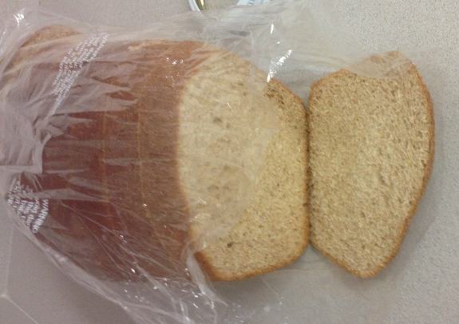
2/3 C. Olive Oil
2/3 C. Honey
1 T. Salt
2 T. Soy Lecithin
1000 mg Vitamin C
½ C. Vital Wheat Gluten
2 Eggs
2 Heaping Tablespoons Dry Instant Yeast
10 – 15 C. Freshly Ground Whole Wheat Flour

Combine water, oil, honey, salt, soy lecithin, vitamin C gluten flour, and eggs. Mix well.
Add 6 cups flour and mix. Add yeast. Switch to dough hook. Add flour until dough doesn’t stick to sides of bowl. Knead for 10 minutes with kneading hook on medium speed. Form into 5 loaves. (If you have a scale weigh 1.25 lbs. per loaf) Place in greased bread pans. Rise until double. Bake bread at 350° F for 20-25 minutes. Remove from pans and cool.

Raspberry Rhubarb Jam
Mary Jane Ricks
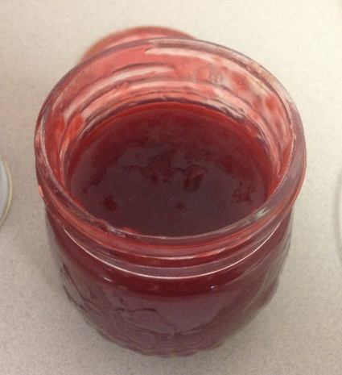
4 ½ C. Diced rhubarb
4 ½ C. Raspberries
2 T. Lemon juice (always use concentrate when canning)
6 T. Low-sugar powdered fruit pectin (or 2 1.75 oz. boxes)
½ t. Butter (Real butter keeps the foam down)
7 C. Sugar
4 ½ Pint Canning jars with lids and rings

Place your fresh fruit in a large pot over medium heat. (I cooked my rhubarb first in water to soften. Drained and mashed it so it didn’t have large chunks)
Stir into fruit mixture: lemon juice, fruit pectin, and butter. Once it begins to juice, add sugar, 1 cup at a time. Stir constantly until juice starts to simmer. Bring to a full rolling boil (means it doesn’t quit boiling when you stir) and cook and stir for 1 minute.
Have washed jars ready and using a jelly funnel and pack with the hot jab to within ¼ inch from the top. Wipe the rims with a damp towel and then place the hot lids on a screw rings down.
Have a large stockpot of water heated. Bring to a boil, and lower the jars inside with space surrounding each jar. Add more hot water if needed until water level is at least 1 inch above jars. Bring water to a full boil. Cover and process for 10 minutes.
Remove jars from stockpot and place on a folded towel until cool.

Peanut Butter Cups
Denise Harris
2 C. Peanut Butter
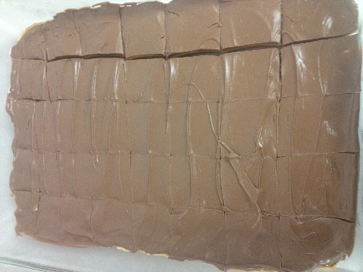
¼ C. Softened Butter
½ C. Brown Sugar
½ t. Vanilla
2 ½ C. Powdered Sugar

Blend of knead above ingredients. (If mixture is too oily, add more powdered sugar.)
Press into 9 X 13 pan.

1 ½ C. Chocolate Chips
2 T. Margarine

Melt and spread over mixture. Cool 10 minutes and cut.
If chocolate mixture is thick, add drops of milk.

Gelatin Pinwheel/ Fruity Roll-Ups
Rebecca Harris
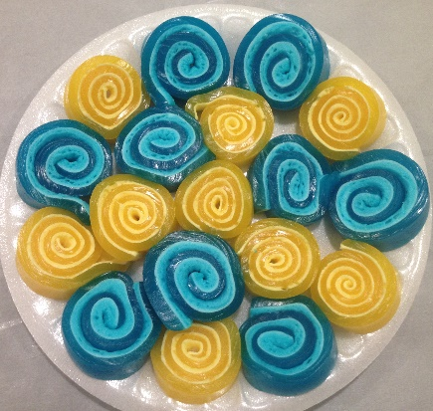
1 (3 oz.) pkg. Jell-O
½ cup water
1 ½ cups miniature marshmallows

Lightly spray an 8 or 9 inch pan square pan with non-stick cooking spray and make sure it is spread well.

Stir together water and Jell-O powder in a glass bowl and microwave for 1 minute. Remove bowl and stir well making sure Jell-O is dissolved. If necessary, return to microwave for 20 seconds or so to make sure Jell-O is dissolved and stir again.

Add marshmallows and return to microwave for 20-40 seconds or until marshmallows have just begun to puff. This is the key to a successful marshmallow layer! If you over cook the marshmallows, they just dissolve and your roll-up will not have two distinct layers.

Whisk quickly until marshmallows are dissolved.

Pour quickly into prepared pan and chill in fridge for 45 minutes or until well set. Creamy layer will float to the top.

Remove the pan from fridge. At this point, the Jell-O should be very firm and easy to handle. Gently pull one side away from pan and lift entire sheet onto counter. Starting at one end, roll up tightly. With seam side down, cut into 10-12 (½) inch slices. We found it easiest to cut with a piece of thread or dental floss. Just put the string around roll-up, cross and pull.

